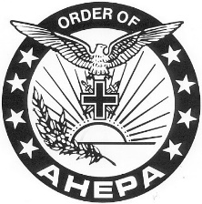
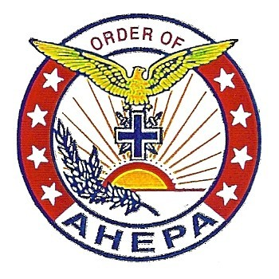
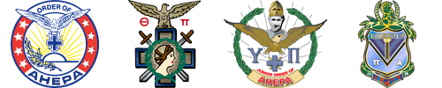
John G. Thevos District #5 2016-2017 District Directory

Visit Our District Website: www.ahepadistrict5.org

ORDER OF AHEPA
American Hellenic Educational Progressive Association

2016-2017 Membership Directory
Version 1.0.5
November 2016

John G. Thevos District #5
New Jersey & Delaware

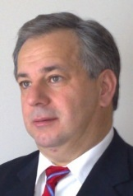
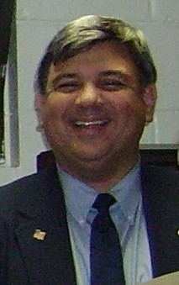
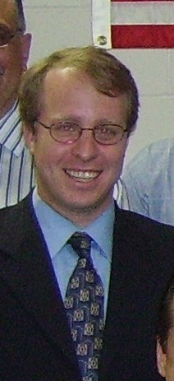
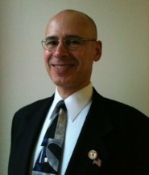
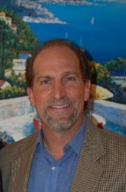
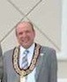
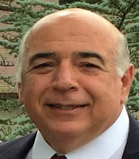
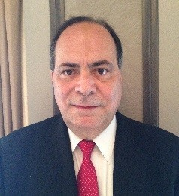

EXECUTIVE BOARD:
District #5 Lodge Officers
ory

(856) 489-5880 (Cell)
2016-2017 District Direct
Marm1025@gmail.com
Camden Chapter #69

District Governor George N. Petrakakis 47 South Shore Drive South Amboy, NJ 08879 (732) 522-3797 (Cell)
gpetrakakis@outlook.com
Raritan Chapter #288

District Lieutenant Governor,

Zenon Christodoulou PhD. 34 Fox Chase Run
North Branch, NJ 08876 (908) 400-0886 (Cell)
zenon@christodoulou.net
Hudson Chapter #108

District Secretary
Jimmy Rozanitis 1441 South 19th Street Philadelphia PA 19146
(856) 625-6708 (Cell)
drozanitis@gmail.com
Camden Chapter #69

District Treasurer Steven Marmarou
7 Rose Lane
Cherry Hill, NJ 08002 (609) 206-9447 (Home)

LODGE MEMBERS:

District Warden

Robert Fourniadis 38 Nicklaus Lane
Farmingdale, NJ 07727
(732) 751-1174 (Home)
(732)259-3894 (Work)
Bfourniadis@optonline.net
Camden Chapter #69

District Marshall,

George Pappas 6 Shelfield Lane
Mount Laurel, NJ 08 (856) 222-0502 (Home)
(856) 906-6012 (Cell)
Georgepappascpa@gmail.net
Camden Chapter #69

District Athletic Advisor,

Asteris Fanikos PDG 31 Recklesstown Way
Chesterfield, NJ 08505
(609) 462-5634 (Cell)
(609) 633-2679 (Work)
afanikos@hotmail.com Trenton Chapter #72

Sons District Advisor,

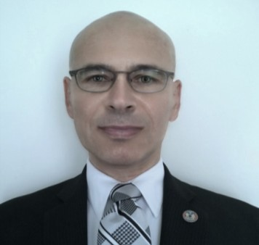
Meet your District Lodge Officers:

George N. Petrakakis, District Governor.

Brother George is a 36 year member of the AHEPA and Past President of Alexander Hamilton #54 of Paramus; and a four term Chapter Secretary of the Fighting 54.This is his fourth consecutive year on the District Lodge. George spearheaded the 2015 reactivation of the Perth Amboy AHEPA Raritan Chapter #288, after being defunct for nearly twenty years. George began his time in the
AHEPA family as a member of the Sons of Pericles Marathon #46 of Paterson, NJ. There he served on the Supreme Lodge and District Lodges (as Supreme Governor and District Secretary respectively). He also was chairman of the 1981 ISMIBT (International Sons and Maids Invitational Basketball Tournament). George is a retired Paterson Police Lieutenant having served twenty-nine years in Law Enforcement; currently works as a Licensed Private Investigator, and holds a Real Estate License with Weichert Referral Associates. He has served on two Parish Councils – most recently for eight years at St. Demetrios Church of Perth Amboy; and six years during the 1980’s at St. Athanasios Church of Paramus. George earned a Bachelor of Science degree from then Jersey City State College in Criminal Justice, while working as a Police Officer; and also a Bachelor of Arts degree from Rutgers University in Urban
Studies / Community Development.

Zenon Christodoulou, Lieutenant Governor
Mission Vice-President of Membership
Chairman, AHEPA District 5 Strategic Planning Committee

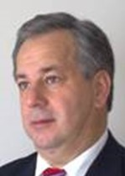
Brother Zenon is a Past President of Hudson Chapter #108 of Jersey City. He is a professor of management’s studies and business consultant. He also owns a printing company and restaurant. He is a member of numerous Hellenic organizations, including the NJ Hellenic American Heritage Commission, on which he is the founding chair and the Washington, DC based Coordinated Effort of Hellenes.

Dimitri Rozanitis, District Secretary
Mission Vice-President of Hellenism
Chairman, AHEPA District 5 Hellenism and Hellenic Culture Committee

Bro. Dimitri, in addition to his duties as District Secretary is the Vice-President of Hellenism and Chairman of the AHEPA District 5 Hellenism and Hellenic Culture Committee.
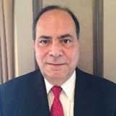
Dimitri has a long history of working for Hellenic causes. This is Dimitri’s third year on the AHEPA District 5 Lodge. He is Past President of Camden Chapter #69 of Cherry Hill. He has also served as Chairman of the Federation of Hellenic Societies of Philadelphia.He has served as Grand Marshall of the Philadelphia Greek Independence Day Parade. Other projects that he has been involved with is the ground breaking of the St Thomas Senior Citizens’ Center and on the Parish Council of St Thomas Greek Orthodox Church.

Steven Marmarou, District Treasurer
Mission Vice-President and Chairman of Education
Brother Steven is a resident of Riverton, NJ. For the past 6 years Brother Steven has been the

Meet your District Lodge Officers:
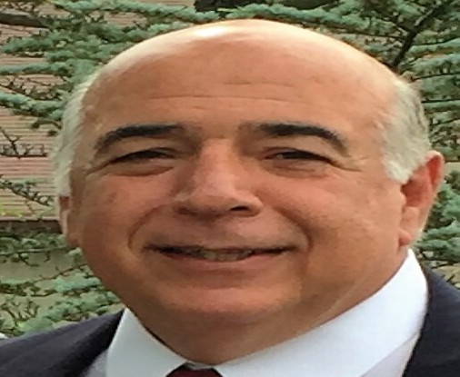
Robert Fourniadis, District Warden Mission Vice-President of Philanthropy Chairman, AHEPA District 5:
- Philanthropy Committee
- Entertainment Committee
- St. Basil Academy Scholarship Committee

Brother Bob, an Ahepan for over 20 years, is one of the founding members of Garden State Chapter #517 and a past 4 term Chapter President. Bob’s family is one of the founding families of Kimisis Tis Theotokou in Holmdel where he
served on the Parish Council for 12 years, including two terms as President and as co-chairman of the building committee while the Church was completing its Community Center in 2000. Bob was honored by his Chapter as Ahepan of the Year in 2014 and was honored as President of the Year by District 5 in 2015. Brother Bob is a licensed attorney and has spent most of his career in real estate development, currently working for Prism Capital Partners as Senior VP of its residential division.

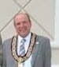
George N. Pappas, District Marshall
Mission Vice-President of Family and Individual Excellence

George Pappas graduated from Rutgers University in 1980, major in Business Administration, concentrating in Accounting. He has his own CPA/Accounting firm in Cherry Hill, NJ where he represents businesses, individuals and non-profit organizations. He is an active member of St. Thomas Parish. He has served as a Parish Council member of Saint Thomas GOC, in Cherry Hill, NJ (1999-2006), 7 years as the Treasurer, 1 year as the President, and Agora Co-
Chairman for the past 20 years. He is currently the Assistant Treasurer. George has proudly served as the President of the Hellenic University Club of Philadelphia whose Scholarship Program is the largest scholarship grant-giving program to students of Greek descent and students with declared majors in Hellenic Studies in the Greater Philadelphia Region for two terms, 20142016. He is the Vice Chairman of the Greek American Chamber of Commerce, an Organization whose goal is to lead young Greek American business people toward success by giving them the opportunity to meet other successful persons in the Greek American community. He is currently the Treasurer of the New Jersey Hellenic Federation.
He has been a SOP and an AHEPAN for almost 30 years and has served as the District #5 Warden and Marshall. He served as President of his local AHEPA Camden Chapter #69 for two terms 2014-2016.
He strongly believes that being deeply involved with the Church and various Hellenic American organizations and societies are of utmost significance for maintaining the values of our Greek Orthodox faith and of major importance for our Hellenic Heritage and history, here in the United States. He is married and has twins, a girl and a boy, aged 10.

Asteris J. Fanikos, PDG
District Athletic Director
Mission Vice-President of Civic Responsibility Chairman, AHEPA District 5 Civic Affairs Committee

Bro. Asteris was elected Athletic Director at the District 5 Convention in Trenton. He has served on the District Lodge for many years and completed his term as District Governor this past May 2016. He is a member and past president of the AHEPA Trenton chapter. Has served for over ten (10) years on the Parish Council for St George in Hamilton and is its 2nd Vice President and is its Youth Advisor. He received the Governor’s Award in 2008 for his actions during the Greek wildfires relief project, was President of the Year
in 2009, a Hermes Expo honoree in 2016, and a Metropolis Clergy-Laity Conference honoree in 2016. He also serves as the Executive Director for the Hellenic American Heritage Commission for the State of New Jersey. Mr. Fanikos is the Senior Staff Attorney for the Office of the State Comptroller for the State of New Jersey. He is married to DOP Lt. Governor Dina Fanikos and has a daughter Evangelia.
(Continued next page)

Visit Our District Website: www.ahepadistrict5.org

Meet your District Lodge Officers:

Ted Vittas, PDG
AHEPA District 5 Sons of Pericles Advisor
Chairman, AHEPA District 5:
- Sons of Pericles Alumni Network
- Family Outreach Committee
- IT and Social Media Committee Job Board Project

Brother Ted is a Past District 5 Governor (2006-2007) and a Past President of both the Liberty & Ramapo Chapters. His is a member of Liberty Chapter #532 in Clifton. He serves on the National Advisory Board of the Sons of Pericles as well as a member of the AHEPA Hall of Fame Selection Committee. Ted is a 30+ year member in AHEPA which started as a member and Secretary of the Hudson Chapter #108 in Jersey City. Ted was also a Past Supreme Governor and PDG of the Sons of Pericles in the 1980s and is currently serving as the District 5 Advisor to the Sons of Pericles and on the Sons of Pericles Alumni Network. Professionally, Ted works as a Marketing Data Analyst for Chubb Insurance Corp. Ted loves to work with technology and hold several certifications in software development. He is a graduate of Saint Peters University (BS) and the NJ Institute of Technology (MS). He is also a certified official in basketball and volleyball.Ted and his wife Valerie met through the AHEPA. They and their two children all are members of the AHEPA Family in each of the four Orders.
District #5 NJ/DE

CHAPTERS BY REGION AREA:
Northern Region-1
- Union-Eureka #52
- Paramus-Alexander Hamilton #54
- Jersey City-Hudson #108
- Tenafly-Bergen Knight #285
- Randolph-Morris County #300
- Roseland-Eagle Rock #375
- Wyckoff-Ramapo #453
- Clifton-Liberty #532
- Perth Amboy-Ratitan Chapter #288
Central Region-2
- Piscataway-Monroe #75
- Westfield-Thomas Jefferson #280 3-Asbury Park-Thomas Edison #287 4-Toms River-Ocean County #467
5-Holmdel-Garden State #517
Southern Region-3
- Cherry Hill-Camden #69
- Trenton-Trenton #72
- Wilmington-Wilmington #95
- Vineland-South Jersey #162
- Wildwood-Wildwood by the Sea #450
Inactive Chapters:
1-Atlantic City-Atlantic City #169 2-Fairview-Fairview #504

District Lodge Officers Liaison to:
CHAPTER’S FINANCIAL OBLIGATIONS:

George N. Petrakakis,

Eagle Rock #375
Garden State #517
- National Per Capita dues $45 per mem. Send payment to AHEPA National Hdqts No Initiations Fee, No Reinstatement Fee.

- District AHEPA Voice $4 per member

Zenon Christodoulou, Tenafly #285
Toms River #467
Camden #69

Jimmy Rozanitis, Asbury Park #287
Trenton #72

Steven Marmarou, Union #52
Monroe #75

George Pappas Vineland #162 Wilnington #95

Robert Fourniadis Cifton #532
Paramus #54
Randolf #300

Ted Vittas, Sons Chapters
Alexander Hamilton #54
Morris County #300
Ramapo #453
Liberty #532 District Scholarship Co-Chairmen:
Steve Lioumis 732-341-5558 Home John Mehos 201-401-6390-Cell Vassos Chrysanthou, Treasurer 732-567-8952

DISTRICT SCHOLARSHIP DEADLINE: APRIL 1st

CHECK WITH YOUR CHAPTER ON THEIR SCHOLARSHIP DEADLINE DATE:
Chapters to send payment to the AHEPA Voice Manager.

- District Scholarship $4 per member
Chapters to send payment to the Scholarship chairman.

- Each Chapter is require to buy 10 tickets, and 1 journal ad $100 for the District Convention, Chapters with 49 members or less you buy 5 tickets.

- Each chapter prior to the District Convention shall submit to the District Lodge the following forms:

  - Chapter report form
  - Chapter delegates form
  - Chapter Officers Elections form
  - Chapter AHEPAN of the year form
*These forms must be mailed to the District Lodge 30 days prior to the District Convention; Forms are available in our website.
*Chapter Election Forms shall be sent to AHEPA National and the District Lodge by the end of June.
*Each Chapter has 6 Delegates for the District Convention.
*Chapter that will host next the District Convention must submit to the District Lodge a
$400 fee as mandated.

REFER TO THE DISTRICT BY-LAWS

Mission District Lodge Vice Presidents

(As mandated in our Constitution, each chapter should elect 5 mission VPs and send the names to the District Governor for inclusion in the directory. They will work together as a District-wide committee.)

Vice President of Membership Zenon Christodoulou zenon@christodoulou.net

Vice President of Hellenism Jimmy Rozanitis drozanitis@gmail.com

Vice President of Education Steven Marmarou Marm1025@gmail.com

Vice President of Philanthropy Robert Fourniadis bfourniadis@optionline.net

Vice President of Civic Affairs Asteris Fanikos Esq afanikos@hotmail.com

Vice Pres of Family & Ind Excellence George Pappas georgepappascpa@verizon.net

PLEASE NOTIFY THE DISTRICT LODGE WHEN A CHAPTER BROTHER HAS PASSED AWAY

AHEPA FAMILY SUNDAY: Normally the 3rd Sunday in May to honor the decease Brothers and Sisters, check date with the Archdiocese

AHEPA Voice Magazine Phil Vogis Business Manager pvogis@verizon.net Ahepavoiced5@gmail.com
To place an ad in the AHEPA Voice, contact the Business Mgr.

AHEPA Voice Editors Lee Millas PDG+BOT Ted Vittas PDG

District Scholarship Foundation Steve Lioumis PDG-Co-Chairmen, Soti234@aol.com
Vassos Chrysanthou PDG -Treasurer,
vassos@prodigy.net

NYC Greek Independence Day Parade Chairman: TBA

Philadelphia Greek Ind Day Parade Chairman: Stathis Karadonis karandonis@verizon.net

District Webmaster-
Ted Vittas/George Righos

District #5 Mailing List Administrator
George Righos PDG Rigos7@verizon.net Ted Vittas PDG vittas@optonline.net

District #5 Email Distribution List:
Ahepad5@HEC.greece.org
Ted Vittas PDG vittas@optonline.net George Righos rigos7@verizon.net

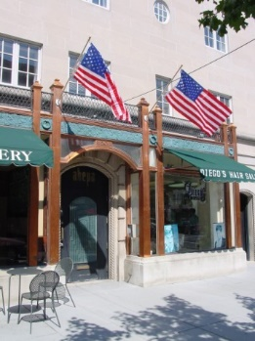
AHEPA Headquarters
1909 Q Street, NW, Suite 500 Washington, DC 20009, USA T.: 202-232-6300
F.: 202-232-2140

www.ahepa.org

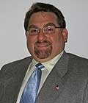
Executive Director

Basil N. Mossaidis
ext.101 bmossaidis@ahepa.org (202) 251-1476 (Cell)

Rosalind Ofuokwu-Membership Director rofuokwu@ahepa.org ext. 107 Patrice P. Farish, CPA, Controller patrice@ahepa.org ext 103
Rory Puckerin, Programs Coordinator rpuckerin@ahepa.org ext 102 Stephanie Maniatis-Administrator admin@ahepa.org ext 100 Webmaster:
webmaster@ahepa.org
Elena V. Skardis, Daughters of Penelope elena@ahepa.org ext 114

Scholarship deadline: March 31st
Delegates forms deadline June 1st Chapters Officers Installations May-June Per Capita deadline: Dec 31st National to send a check to the District for the per capita dues, see By-Laws

Each Chapter has various Delegates to the Supreme Convention, see By-Laws

AHEPA National “Journey to Greece”
Program Director :To be announced AHEPA Headquarters Recommends:
1-Attend the AHEPA Annual Supreme Convention 2-Attend the Annual Congressional Banquet
- Attend the Governors’ Leadership Conference
- Attend Special Functions and support the National projects

AHEPA Cooleys Anemia Foundation
Ike Gulas PSP-Chairperson
205-907-1234
Email: fmgulas@bellsouth.net

AHEPA Bone Marrow Registry
For Canisters contact:
Dr John Venetos 773-989-6262 Email: samv5161@aol.com

AHEPA Bone Marrow Registry
District #5 Ange Pantazes 973-398-0888

AHEPA Awards, Svc Pins, Etc.
Awards Unlimited Co.
800-950-3553 or 402-474-0815
Larry King Co-Owner or Bob www.awardslimited.com

AXIOM Premium Gifts
AHEPA Jewels only 01130 210-531-4994
Cell 01130 697-844-4300

AHEPA’s National Public Relations
Andrew Kaffes:
Director 202-232-6300
Email: Andrew@agkaffes.com

AHEPA National Hospital Committee: Vice Chairman Philip Vogis PSG pvogis@verizon.net

2016-2017 AHEPA Supreme Lodge

OfficersSupreme President D5
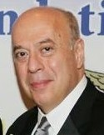
Andrew Zachariades 305 Worth Street
Brick, NJ 08724
W: 212-266-8263
C: 908-419-4053
a.zachariades@att.net

Supreme Vice-President D
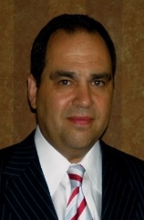
George Lucas R.Ph, J.D. 2550 Chagrin Blvd,. Suite 102
Beachwood, OH 44122 W:216-834-0400
C: 216-956-1234
F: 216-834-0404
GLoucas@loucasLaw.com

Canadian President—AHEPA
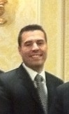
Vasilios “Bill” Bakalis 508 River Bend Drive, Suite 102
Kitchner, Ontario N2K 352, Canada
C: 519-729-3959
F: 519-747-0067
W: 1-866-950-5433 Toll free W: 519-747-0058 Ext 227
Bill.Bakalis@Sunlife.com

Supreme Secretary D11
Carl R. Hollister
6440 Hunters Green Dr. Mason, OH. 45040
W: 800-478-0788 x 105
C: 513-689-0985
supsec@AHEPA.org
Supreme Treasurer D10
Jimmy Kokotas PSG 2341 E.71st Street
Brooklyn, NY 11234
C: 917-584-5599
suprtres@AHEPA.org

Supreme CounselorD05
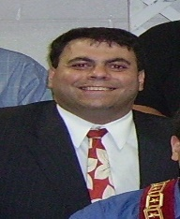
George Horiates Esq. 600 East Camden Ave Moorestown, NJ 08057
C: 856-986-8972
W: 856-986-8972
supcounselor@AHEPA.org

Supreme Athletic DirectorD11
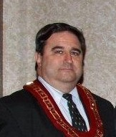
Lou Atsaves PSG
745 East Northmoore Rd Lake Forrest, IL 60045 C; 847-401-1674
O: 312-322-0001
supad@AHEPA.org

Supreme SONs National Advisor
Sandy Papadopoulos 2852 Hawthorne Dr.
Atlanta, Georgia 30345
C: 678-860-6564
Sopadvisor@AHEPA.org

SUPREME GOVERNORS….2016-2017

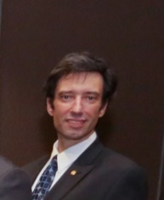
Gus Paras D1-AL,FL,GA,MS,SC,TN
Region – 1
3908 San Miguel
Tampa, Florida 33629
O: 813-598-5212
sg1@AHEPA.org

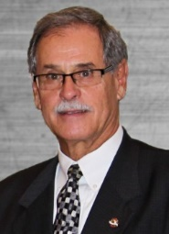
Anthony J. Drakos D3, DC,MD,NC,PA,VI,WV
Region – 2
6009 Kingston Drive
Aliquippa, PA 15001
C: 412-974-9449
sg2@AHEPA.org

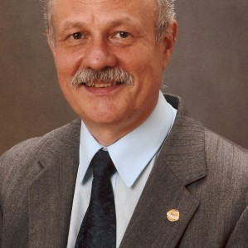
Chris Diamantoukos D5 -NJ, DE, NY
Region – 3
102 Burrwood Avenue Haddon Twp., NJ 08108 H: 856-858-1704
C: 215-260-7734
E: Chrisd37@Comcast.net

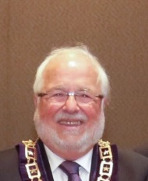
Jack Isaak D8-CT,MA,ME,NH,RI,VT
Region – 4
1515 Sylvan Rd.
New Britain, CT 06053 H: 860-224-2183
Sg4@AHEPA.org

George L. Kalantzis D11-KE,MI,OH
Region – 5
6480 Blossomwood Cir.
Canton, OH 44721
C: 330-936-4080
Sg5@AHEPA.org

Donald Vanover D11- IL,IN,IA,MN,MO,ND,NE,SD,WI
Region – 6
117 Harmony Way Lake City, MN55041 O: 602-667-6379
Sg6@AHEPA.org

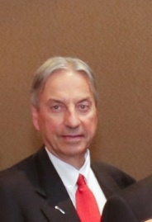
Tim Joannides D17 AR,CO,KS,LA,NM,OK, TX,WY
Region – 7
10013 Wayne Road
Cheyenne, Wyoming 82009
O: 307-634-1511
C : 307-630-0231
Sg7@AHEPA.org

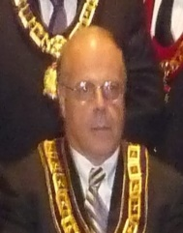
George S. Booras D22 - AK,AZ,CA,HI,ID,MT,NV,OR,VT,WA
Region - 8
PO. Box 1556
Danville, CA 94526
O: 650-855-2471

Sg8@AHEPA.org

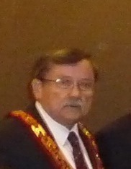
Nick C. Papadopoulos D27 EUROPE
Region 10
14 Papagou Street
Voula, 16673, Greece
C: 011-30-693-232-4807
Sg10@AHEPA.org

2016-2017 Board of Trustees(Elected)

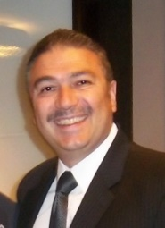
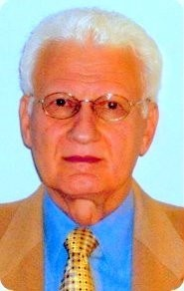
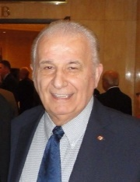
CHAIRMAN:

- Nicholas Karacostas Esq. D6 (2014-2017)
29-20 212 Street
Bayside, NY 11360
H: 718-279-3275
W: 646-746-8189
C: 917-846-6507
nakoraco@aol.com

Vassos Chrysanthou D5 2014-2017)
2212 Arvell Court Toms River, NJ 08755 H: 732-341-2918
C: 732-567-8952
vassos@prodigy.net

Nick Aroutzidis D23 (2015-2018)
43 Guthrie Avenue
Strafford, Ontario, NBA 25th, Canada H: 519-273-6225
C: 519-860-2964
nick@naeng.com

Nick J MatthewsD3(2010-2016)
229 Dogwood Lane Cobbs Creek, VA 23035 H: 804-725-1179
C: 804-815-4321
nickosmatthews@gmail.com

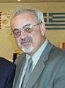
Secretary:

- Lee Millas (2015-2018)
62 Hempstead Road
Hamilton, NJ 08610
H: 609-585-3137
C: 609-658-4372
jlmillas@msn.com

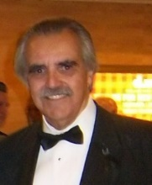
Cosmos Marandos D8 (2013-2016)
102 Peele Road
Nashua, New Hampshire 03062 H: 603-8881010
C: 603-566-0891
marandos@comcast.net

Supreme President D5 (2016-2017) 7-Andrew Zachariades
Sovereign Member

Supreme Auditors: Vasilios Albanos PhD Craig Clawson CPA Mike Papaphotes CPA

PAST SUPREME GOVERNORS FROM DISTRICT #5 NJ/DE

Past Supreme Governors
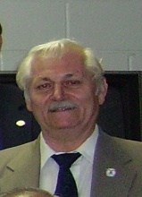
Louis Arvanitis
15 W Grand Avenue Montvale, NJ 07645
(201) 666-8651
Mclouis152@aol.com

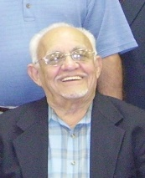
John Mehos
56 Greenville Ave Jersey City, NJ 07305 (201) 333-1081 (Home)
(201) 401-6390 (Cell)
j.mehos@verizon.net Hudson Chapter #108

Andrew C. Zachariades 305 Worth Street
Brick, NJ 08724
(732) 458-8782 (Home)
(212) 266-8263 (Work)
(908) 419-4053 (Cell)
a.zachariades@att.net Hudson Chapter #108

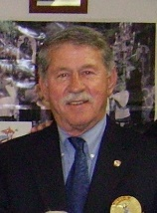
Ted Fanikos
265 Ward Avenue
Bordentown, NJ 08505
(609) 313-8085
Taf265@aol.com Trenton Chapter #72

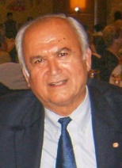
Philip (Phil) Vogis 151 Fernwood Drive Old Tappan, NJ 07675
(201) 664-1534 (Home)
(551) 206-4110 (Cell)
pvogis@verizon.net

Member, Board of Trustees

Vassos Chrysanthou 2212 Arvell Court Toms River, NJ 08755 (732) 341-2918 (Home)
(732) 567-8952 (Cell)
Vassos@prodigy.net Ocean City Chapter #467

Past Member: Board of Trustees
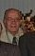
Ernie Tsaptsinos 2464 Spring Hill Dr
Toms River, NJ 08755 (732) 942-0083 (Home)
Sula38@msn.com
Ocean County Chapter #467

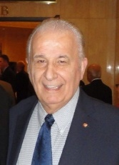
Lee Millas
62 Hempstead Road
Hamilton, NJ 08610
(609) 585-3137 (Home)
(609) 658-4372 (Cell)
jmillas@msn.com Trenton Chapter #72

D-5 Projects Committee Chairman
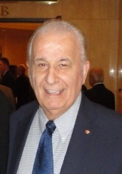
Lee Millas
62 Hempstead Road
Hamilton, NJ 08610
(609) 585-3137 (Home)
(609) 658-4372 (Cell)
ljmillas@msn.com Trenton Chapter #72

DISTRICT 5 SCHOLARSHIP:
District Scholaship deadline and AHEPAcademy Deadline is April 1st
Alamo Flags 800-882-3524

PAST SUPREME PRESIDENTS FROM DISTRICT #5 NJ/DE

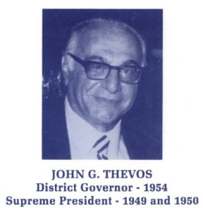
- John G. Thevos-PSP 1949-1950 and 1950-1951 (Deceased)
Alexander Hamilton Chapter #54 Paramus, NJ

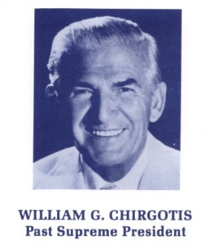
- William G. Chirgotis PSP 1974-1975 and
1975-1976 (Deceased)
Eureka Chapter #52 Newark, NJ

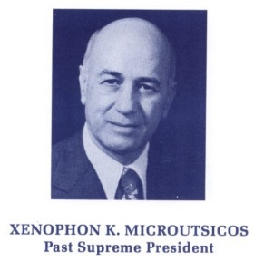
- Xenophon K. Microutsicos PSP 1976-1977 (Deceased)
Trenton Chapter #72 Trenton, NJ

Past District #5 Governors Past District #5 Governors

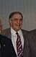
Herbert P. Allen (1978-1980)
226 Sheridan Road
Trenton, NJ 08619
(609) 587-3065
hpapdg@verizon.net Trenton Chapter #72

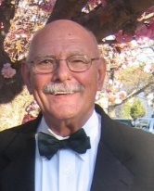
Athan Anest (1975-1976) 2440 Virginia Ave. NW D905 Washington, DC 20037
(202) 775-4389 (Home)
xanthipix@gmail.com Thomas Edison Chapter #287

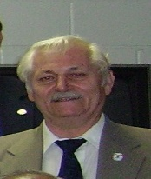
Louis Arvanitis (1983-1984) 15 W Grand Avenue Montvale, NJ 07645
(201) 666-8651
mclouis152@aol.com

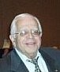
George Burlotos (1961-1962) 606 Cooper Landing A-4E Cherry Hill, NJ 08002
(856) 482-5681 (Home)
(609) 457-1742 (Cell)
georgebulotos@gmail.com Camden Chapter #69

Vassos Chrysanthou (2002-03)
2212 Arvell Court Toms River, NJ 08755 (732) 341-2918 (Home)
(732) 901-9071 (Work)
(732) 567-8952 (Cell)
vassos@prodigy.net
Ocean County Chapter #467
Chris Coroneos (1995-1996)
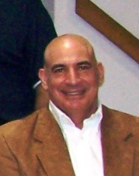
202 Congress Rd
Emerson, NJ 07630
(201) 262-2987 (Home)
ahepagov@aol.co
Bergen Knights Chapter #285

Chris Diamantoukos (2007-2008)
102 Burrwood Ave
Haddon Township, NJ 08108 (856) 858-1704 (Home)
(215) 448-5126 (Work)
(215) 260-7734 (Cell)
chrisd37@comcast.net Camden Chapter #69

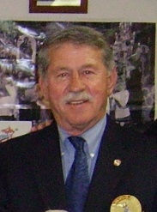
Ted Fanikos (2008-2009)
265 Ward Avenue
Bordentown, NJ 08505
(609) 298-6764 (Home)
(609) 313-8085 (Cell)
Taf265@aol.com Trenton Chapter #72

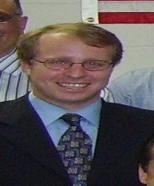
Asteris Fanikos Esq.(2015-16)
31 Recklesstown Way
Chesterfield, NJ 08846
(609) 462-5643 (Ceii)
(609) 633-2679 (Work)
afanikos@hotmail.com Trenton Chapter #72

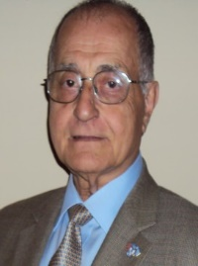
Stanley Gerondelis (2014-2015)
773 Greenbrook Road
Middlesex, NJ 08846
(732) 356-5844 (Home)
(732) 236-4978 (Cell)
sgerondelis@aol.com Monroe Chapter #75

Past District #5 Governors (Cont’d)

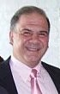
William A Harrison (2012-2013) 716 Avenue C
Bayonne, NJ 07002
(201) 455-3625 (Home)
(201) 966-3766 (Cell)
Bill1955@aol.com Hudson Chapter #108

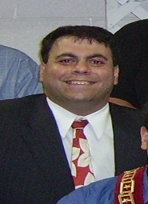
George G Horiates Esq. (2010-11) 600 East Camden Ave Moorestown, NJ 08057
(856) 722-1933 (Home)
(856)986-8972 (Cell)
gghoriates@aol.com Camden Chapter #69

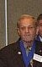
Norman James (1993-1994)
1827 Whitecomb Road Forked River, NJ 08731 (609) 693-9021 (Home)
nvj4@comc
Ocean County Chapter #4

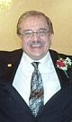
George Karatzia (2005-2006)
24 Longfellow Terrace
Morganville, NJ 07751
(732) 536-6801 (Home)
(732) 610-6622 (Cell)
baklavausa@yahoo.com Garden State Chapter #517

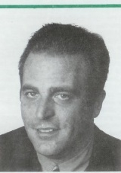
Nicholas Konides (2000-2001) 300 JFK Beach Dr
North Wildwood, NJ 08260 (609) 368-5400 (Home)
ndk@snip.net Wildwood Chapter #450

Past District #5 Governors (Cont’d)

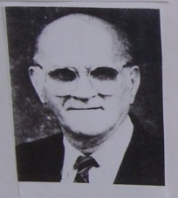
Gust Kraras (1983-1984) 26 E Lancaster Ave Reading, PA 19607
(800) 437-2323 (Work)
(610) 678-7714 (Home)
gkraras@whitestartours.com Wildwood Chapter #450

Spiros(Phil)Livanis (1970-1971)
222 Prince St.
Bordentown, NJ 08505
(609) 298-5446 (Home)
splivanis@verizon.net Trenton Chapter #72

Steve Lioumis (1999-2000)
1690 Todd Road Toms River, NJ 08755
(732) 341-5558 (Home)
Soti234@aol.com
Ocean County Chapter #467

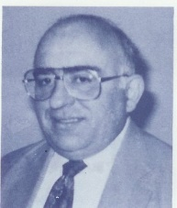
Chris Mantzavinos (1984-1985)
1401 Penn Ave, Unit 204
Wilmington, DE 19806
(302) 656-8828 (Home)
No email
Wilmington Chapter #95

Past District #5 Governors (Continued) Past District #5 Governors (Continued)

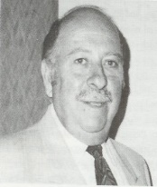
John J Mavrakis (1994-1995) Agia Irini, Magoula-Sparti Lakonia, 23100 Greece
011302731022205
Spartakus.magoula@gmail.com Monroe Chapter #75

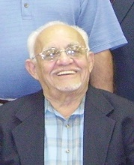
John Mehos (1988-1989)
56 Greenville Ave Jersey City, NJ 07305 (201) 333-1081 (Home)
j.mehos@verizon.net Hudson Chapter #108

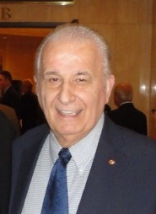
Lee Millas (1974-1975)
62 Hempstead Road
Hamilton, NJ 08610
(609) 585-3137 (Home)
(609) 658-4372 (Cell)
ljmillas@msn.com Trenton Chapter #72

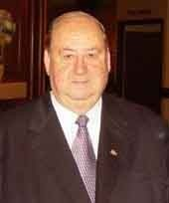
George Righos (2001-2002)
815 Naudain Avenue
Wilmington, DE 19703
(302) 798-3052 (Home)
(302) 897-9431 (Cell)
Rigos7@verizon.net Wilmington Chapter #95

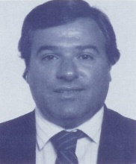
Costas Sedereas (1985-1986)
11 Nina Place
Randolph, NJ 07869
(973) 895-7310 (Home)
(973) 366-7244 (Work)
(201) 874-3691 (Cell)
cpsjets@gmail.com
Morris County Chapter #300
Chris B Sevast (1991-1992) 325 Brookline Ave
Cherry Hill, NJ 08002 (856) 667-1225 (Home)
Camden Chapter #69 cbsevast@yahoo.com

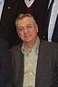
John Tarabicos (1990-1991) 5802 Stone Pine Rd Wilmington, DE 19808
(302) 239-4950 (Home)
(302) 893-1116 (Cell)
jdtaras@aol.com Wilmington Chapter #95

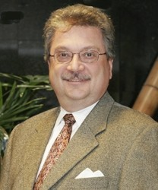
Sammy Thomas (2013-2014)
35 Walthery Avenue
Ridgewood, NJ 07450
(201) 652-0463 (Home)
(201) 724-3698 (Cell)
Sjt49@columbia.edu Ramapo Chapter #453

Ernie Tsaptsinos (1986-1988) 2464 Spring Hill Drive
Toms River, NJ 08755 (732) 942-0083 (Home)
Sula38@msn.com
Ocean County Chapter #467

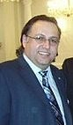
Savas Tsivicos (2011-2012) 524 Green Grove Road Wayside, NJ 07712
(732) 493-9351 (Home)
(732) 299-1532 (Cell)
tsivikos@aol.com
Thomas Edison Chapter #287

Past District #5 Governors (Continued)

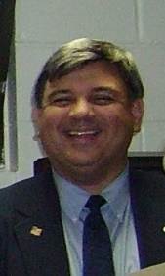
Ted Vittas (2006-2007)
31 Longport Rd
Wayne, NJ 07470-6434
(973) 839-4609 (Home)
(973) 513-3672 (Cell)
vittas@optonline.net Liberty Chapter #532

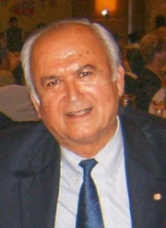
Philip (Phil) Vogis (2009-2010) 151 Fernwood Drive
Old Tappan, NJ 07675 (201) 664-1534 (Home)
(201) 652-4774 (Work)
(551) 206-4110 (Cell)
pvogis@verizon.net Ramapo Chapter #453

Steve Xanthacos (2004-2005)
1625 Dumont Terrace
Wall, NJ 07718
(732) 556-6342 (Home)
(732) 685-4879 (Cell)
greekxman@optonline.net Ocean County Chapter #467

Andrew C. Zachariades (2003-2004) 305 Worth St.
Brick, NJ 08724
(732) 458-8782 (Home)
(212) 266-8263 (Work)
(908) 419-4053 (Cell)
a.zachariades@ att.net Hudson Chapter #108

North: Arvanitis, Coroneos, Harrison, Mehos, Sedereas, Thomas, Vittas, Vogis, Zachariades,

Central: Anest, Fanikos, Livanis, Mavrakis, Millas, Tsivicos,

Southern: Burlotos, Chrysanthou, Horiates, James, Konides, Karatzia, Kraras, Lioumis, Mantzavinos, Righos, Sevast, Tarabicos, Tsaptsinos, Xanthakos,

+ In Memory of the Deceased PDGs

1930 James Veras-District #2
1931-2 John Givas-District #2
1933 James N Pappas-District #2
District #5 was established in 1934
1934 Andrew N Angelson-Alexander Hamilton 1935 Spiros Pappaylio - Thomas Edison
1936 George Galanes-Eureka 1937 James A Millas-Trenton
1938,40,41, Jean M Kossarides-Eureka 1939 Sidney P Skokos-Trenton
1942-3 John A Givas-Eureka
1944 John G Thevos-Alexander Hamilton 1945 Steve Kargakos-Eagle Rock
1946 Nicholas Saros-Thomas Jefferson 1947 James A Millas-Trenton
1948 Kurt M Sinner-Bergen Knights 1949 James G Argyros-Thomas Jefferson 1950 X K Microutsicos-Trenton
1951 Peter Caravoulias-Hudson
1952 William Economides-Bergen Knights 1953 Milton Marikakis-Monroe
1954 Edmund Matsoukas-Hudson
1955 George Stathakis-Alexander Hamilton 1956 George J Andresakes-Eagle Rock, 1957 James Katramados-Eureka
1958 Harry P Karis-Bergen Knights 1959 John Trilly-Hudson
1960 Nicholas Stroumtsos-Monroe 1964 Dean S Papanou-Ramapo
1965 Frank D Gramas-Wildwood by the Sea 1966 Michael Melissas-Camden
1967 Charles Dekis-Tenafly
1968 Thomas Taros-Thomas Jefferson 1969 Basil Manion-Alexander Hamilton 1970 Dino Callas-Bergen Knights
1971 Peter Karas-Bergen Knights 1972 Nick Chrisicos-Thomas Edison 1976-7 Solon Petrides-Bergen Knights 1990 Julian “Woody” West-Camden
1994-6 John K. Antholis-Thomas Jefferson 1997 Nicholas Paras PSG-Eureka
1998 John Sitaras-Wilmington
1999 Louis Stavrakis-Thomas Jefferson 2013 Thomas Pappas-Ramapo
2016 Spiros (Phil) Livanis

Chapter Name: Eureka #52 Established: December 9, 1924 Chapter City: Union, NJ Mailing Address: 82 Hillside Avenue
Springfield, NJ 07081 Meeting Night: 4th Tuesday-7pm Meeting Place: TBA

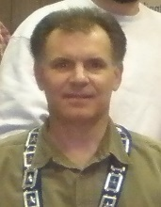
President
Michael T Paskas 82 Hillside Avenue
Springfield, NJ 07081
(973) 467-4156 (Home)
(973) 477-3799 (Cell)
paskasfuneralsvc@aol.com

Chapter Name: Alexander Hamilton #54 Established: September 17, 1924

Chapter City: Paramus, NJ #54 Mailing Address: Same as below Meeting Night: 2nd Tuesday-7:30pm Meeting Place: TBA

President
John M. Kontolios 78 Friend Terrace
Harrington Park, NJ 07640 (201) 784-3418 (Home)
(201) 615-0239
ionkon@hotmail.com

Priest:

Vice President
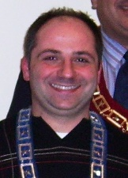
Andreas Yanniotis
210 Claremont Avenue
Verona, NJ 07044
(973) 857-0313 (Home)
(908) 672-0925 (Cell)
Andreas.yanniotis2 @comcast.net

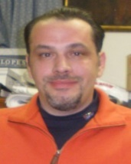
Secretary
James Caplanis 29 Mayfair Drive
West Orange, NJ 07044 (973) 669-5987 (Home)
(973) 951-7706 (Cell)
jdcaplanis@comcast.net

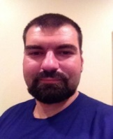
Treasurer
Lucas Loucopoulos 1129 Liberty Avenue
Union, NJ 07083
(908) 578 –9021 (Home)
doctorluke78@msn.com
Vice President Jerry Markopoulos 40 Leach Avenue
Park Ridge, NJ 07656 (201) 788-0007
jmarcopoulos@optionline.net

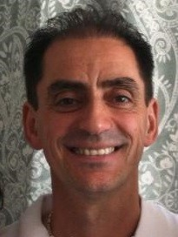
Secretary
Michael H Kovoros 852 Hillsdale Ave
Hillsdale, NJ 07642
(201) 263-0503
mkorovos@hotmail.com

Treasurer
Dionisios Koukounaras 114 Park Ave
West Caldwell, NJ 07006 (201) 953-6354 (Work)
litohoro@aol.com

Priest: Fr Anargyros Stavropoulos- 201-368-8881

Chapter Name: Camden #69 Established: July 30, 1925 Chapter City: Cherry Hill, NJ Mailing Address: Same as below Meeting Night: 2nd Wednesday-7:30p Meeting Place: St Thomas Church
615 Mercer St
Cherry Hill, NJ 08002

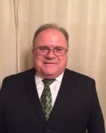
President
Louis Stefanou
4 Upson Circle, Deptford, NJ 08096
856-845-6446
856-693-1157 (Cell)
Lnstanz@yahoo.com

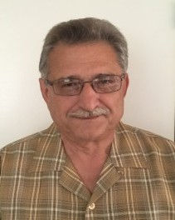
Vice President
Nicholas T. Anagnostos
3 Creekdale Dr., Delran, NJ 08075
(856) 906-1741 (Cell)
anagnostos@comcast.net

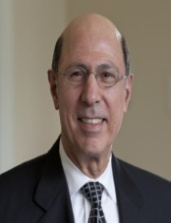
Secretary
John Anagnostis 204 Lamp Post Lane
Cherry Hill, NJ 08003 (856) 424-7029
(609) 206-3491 (Cell)
jta204@gmail.com

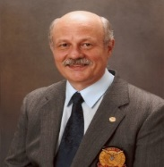
Treasurer
Chris Diamantoukos 102 Burrwood Ave,
Haddon Township, NJ 08108 (856) 858-1704
(215) 260-7734 (Cell)
chrisd37@comcast.net

Priest: Fr. Christoforos Oikonomidis
Chapter Name: Trenton #72 Established: June 23, 1925
Chapter City: Trenton, NJ Mailing Address: Same as above Meeting Night: 1st Monday-7:30pm
Meeting Place: AHEPA House (609) 396-4255
340 William St
Trenton, NJ 0861

President
Dino Demetriou
2083 Brookshire Road
Furlong, PA 18925
(215) 262-2291 (Cell)
(215) 794-4151 (Home)
dinodemetriou@msn.com

Vice President
Steve Stylianou
38 Hawthorne Lane East Windsor, NJ 08520 (609) 448-2531 (Home)
(609) 588-4888 (Cell)
fbmllc@yahoo.com

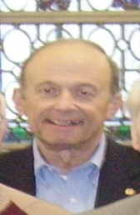
Secretary
Jim Knicos
797 Estates Blvd
Mercerville, NJ 08619
(609) 587-4304 (Home)
(609) 915-3246 (Cell)
kappa59@aol.com

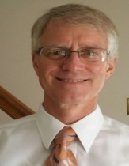
Treasurer
Richard Roscoe
16 Timberwolf Drive
Hamilton, NJ 08620
(609) 838-0211 (Home)
(609) 213-6287 (Cell)
rickyjhpts@aol.com

Priest: Fr James Pavlow - 609-586-4448

Chapter Name: Monroe #75 Established: June 26, 1925 Chapter City: Piscataway, NJ Mailing Address: Same as below Meeting Night: 4th Wednesday-7:30pm Meeting Place: St George Church
1101 River Road & View Piscataway, NJ 08854

President
Michael Gianakos
16 Crystal Dr.
Lebanon, NJ 08833
(H) 908-735-2218
E: Michael0602@yahoo.com

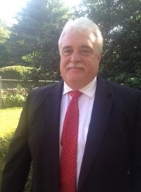
Vice President Dean Solomos 1122 Cain Court
Belle Nead, NJ o8502 (H): 609-651-6851
dvs0978@gmail.com

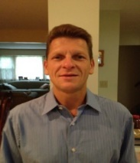
Secretary
Thomas W Sulich 161 Johnson Avenue
Hillsborough, NJ 08844
(908) 253-8685 (Home)
(609) 580--4211 (Work)
tsuli6@verizon.net

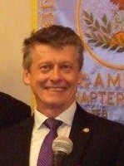
Treasurer Matt Szela
6 Wilson Cove
Hillsborogh, NJ 08844
(908) 874-8311 (Home)
(732) 692-0726 (Work)
mszela@gmail.com

Priest: Fr Nick Pastrikos 732-463-1642
Chapter Name: Wilmington #95 Established: February 14, 1926 Chapter City: Wilmington, DE Mailing Address: Same as below.
Meeting Night: 2nd Tuesday 7:30pm
Meeting Place: Holy Trinity Church
808 North Broom St Wilmington, DE 19806

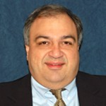
President Michael Kirifides
2402 Newton Road
Wilmington, DE 19810
(302) 478-3529 (Home)
(302) 897-9429 (Cell)
mkirifides@aim.com

Vice President
Stephanos Karakasides
181 Christina Landing Drive Wilmington, DE 19801
302-652-1779(H)
skarakas@comcast.net

Secretary
Ken Przywara 703 Cardiff Road
Wilmington, DE 19803
(302) 478-8321 (Home)
(302) 584-8377 (Cell)
ken@przywara.com

Corr Sec: Louis Novakis

Treasurer
Dino Charalambides 413 Stella Dr.
Hockessin DE 19707
(508) 981-3954 (Cell)
k.charalambides@gmail.com

Priest: Fr Christos Christofidis- 302-654-4446

Chapter Name: Hudson #108 Established: July 19, 1926 Chapter City: Jersey City, NJ Mailing Address: 661 Montgomery St
Jersey City, NJ 07306
201-432-2488
Meeting Night: 3rd Tuesday-8pm
Meeting Place: Evangelismos Church
661 Montgomery St Jersey City, NJ 07306

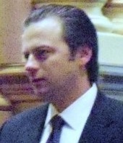
President
William Matsikoudis Esq 4 Beacon Way Apt 322 Jersey City, NJ 07304 (732) 771-4525 (Cell)
matsikoudi@aol.com

Vice President
Stathis Theodoropoulos 402 Elm Street
Karney, NJ 07032
(201) 889-7493 (Cell)
stathistheo@gmail.com

Secretary
William A Harrison PDG 716 Avenue C
Bayonne, NJ 07002
(201) 455-3625 (Home)
(201) 966-3766 (Cell)
Bill1955@aol.com

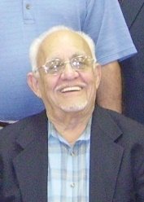
Treasurer
John Mehos PSG 402 Elm Street
Jersey City, NJ 07305 (201) 333-1081 (Home)
(201) 401-74936390 (Cell)
j.mehos@verizon.n

Priest: Fr, Nick
Chapter Name: South Jersey #162 Established: March 7, 1928 Chapter City: Vineland, NJ Mailing Address: Same as below Meeting Night: 1st or 3rd Wednesday Meeting Place: St Anthony’s Church
430 W Wheat Rd Vineland, NJ 08360

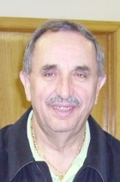
President Eleftherios Klekos 1291 McClain Dr
Vineland, NJ 08361
(856) 696-3578 (Home)
(609) 381-4247 (Cell)
peterd@pcom.edu

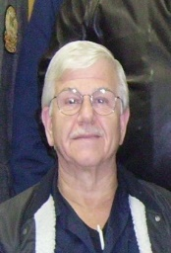
Vice President Kostas Dimitrios 85 S. Orchard Rd Vineland, NJ 08360
(856) 692-4012 (Home)
(856) 692-2291 (Alt.)
No email

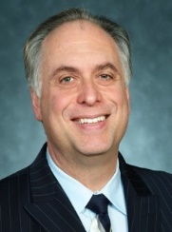
Secretary
Peter Doulis
748 Magnolia Road
Vineland, NJ 08360
(856) 691-6952 (Home)
(215) 852-8519 (Cell)
peterd@pcom.edu

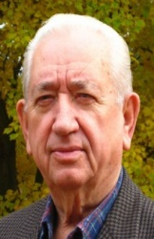
Treasurer
Gus Giannikopoulos
1518 James Court
Vineland, NJ 08361
(856) 696-8431 (Home)
No email

Priest: Fr Paul Panos-Ahepan 856-696-0917

Chapter Name: Thomas Jefferson #280 Established: June 20, 1931
Chapter City: Westfield, NJ Mailing Address: Same as below Meeting Night: 3rd Thursday-7:30pm Meeting Place: Holy Trinity Church
250 Gallows Hill Rd. Westfield, NJ 07090

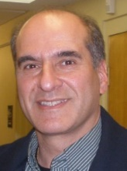
President
Evans John (Acting Secretary) 29 Murphy Circle
Florham Park, NJ 07932 (973) 377-6158 (Home)
(973) 600-7675 (Cell)
Angelos.john@siemens

Vice President Chair vacant TBD

Secretary REMOVE

Treasurer Chair Vacant

Priest: Fr Peter Delvizis 908-233-8533
Chapter Name: Bergen Knights #285 Established: August 27, 1931 Chapter City: Tenafly, NJ
Mailing Address: Same as below Meeting Night: 2nd Wed-7:30pm Meeting Place: St John Theologian
353 East Clinton Ave Tenafly, NJ 07670

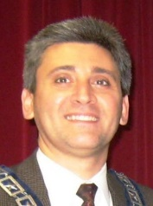
President
Dr Demetrios Bayiokos DDS 12 Council Place
Harrionton Park, NJ 07640 (201) 750-9189 (Cell)
(201) 944-8305 (Work)
dbayiokos@optonline.net

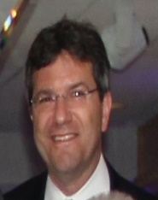
Vice-President Dr Peter B Hilaris 1 Yale Place
Closter, NJ 07624
(201) 750-9173 (Home)
(201) 343-5277 (Work)
hilarispb@aol.com

Asst Secretary Andreas Zigouras Secretary Kypros Lambiris

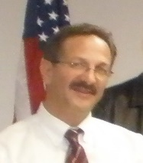
Treasurer Constantine Mikelis 333 Canterbury Lane
Wyckoff, NJ 07481
(201) 244-5666 (Home)
(201) 925-0925 (Cell)
cmikelis@ihavenet.com

Priest: Fr Panayiotis Zougras (Ahepan) 201-567-5072

Chapter Name: Thomas Edison #287 Established: October 29, 1931 Chapter City: Asbury Park, NJ Mailing Address: Same as below Meeting Night: 2nd Monday-7:30pm Meeting Place: St George Church
1155 W Park Avenue Ocean Township, NJ 07712

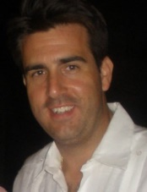
President:
Dr Kostas Linardakis 220 Branch Avenue Little Silver, NJ 07739 (732) 747-8065 (Home)
(732) 747-7333 (Work)
(732) 539-3455 (Cell)
drkosta@verizon.net

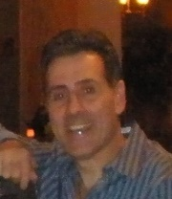
Vice President Theodore Kavarakas 721 Talmadge Avenue
Oakhurst, NJ 07755
(732) 620-8871 (Cell))
kavarakas@aol.com

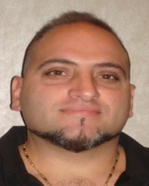
Secretary
Semos Kostidakis 22 Woodrow Street
Oakhurst, NJ 07755
(732) 616-3459 (Cell)
semos@optonline.net

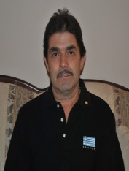
Treasurer
Peter Thomas
109 Cold Indian Springs Rd Ocean, NJ 07712
(732) 922-3159 (Home)
(908) 489-3944 (Cell)
koroni1@hotmail.com

Priest: Fr Andrew Eugenis- 732-775-2777
Chapter Name: Raritan #288 Established: January 21, 1932 Chapter City: Perth Amboy, NJ Mailing Address: Same as meeting place Meeting Night: 3rd Thursday – 8:00pm Meeting Place: St Demetrios Church
41-47 Wisteria Street Perth Amboy, NJ 08861

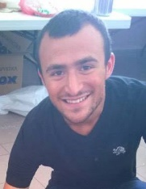
President:
Nick Vosinas
24 McPherson Avenue
Metuchen, NJ 08840 nvosinas@gmail.com

Vice President
Dimitrios Koudis
277 S. Washington Ave. Dunellen, NJ 08812
848-203-1762
dimikou@gmail.com

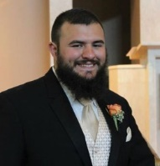
Secretary
George Vosinas
24 McPherson Avenue
Metuchen, NJ 08840 gvosinas@gmail.com

Treasurer
To Be Appointed

Priest:

Chapter Name: Morris County #300 Established: August 12, 1934 Chapter City: Randolph, NJ Mailing Address: 1447 Sussex Turnpike
Randolph, NJ 07869 Meeting Night: 1st Wednesday-7pm Meeting Place: St. Andrew's Church,
Sussex Tpke. Randolph, N.J.

President
Christos Petrou
40 Musconetcong Avenue
Hopatcong, NJ 07843
(973) 800-4190 (Cell)
(973) 288-1514 (Home)
Petrou.christos@gmail.com

Vice President Thomas J Borzekas 5 Intervale Road
Boonton, NJ 07005
(973) 355-7538 (Home)
tjborzekas@yahoo.com

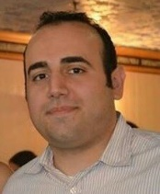
Secretary
Demetri Rotsides
18 Glenwood Avenue
Randolph, NJ 07869
(973) 328-4851 (Home)
drotsides@aol.com

Treasurer
Peter Tsilios
6 McKinley Street
Stanhope, NJ 07874
(862) 258-0931 (Home)
ptsilios@gmail.com

Priest: Fr John Theodosion- 973-584-0388
Chapter Name: Eagle Rock #375 Established: May 31, 1950 Chapter City: Orange, NJ Meeting Night: 1st Tuesday7:30pm
Meeting Place: Ss Nicholas, Constantine & Helen Church 80 Laurel Avenue
Roseland, NJ 07068
Website: ahepa375.org/

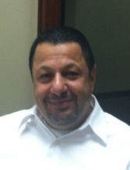
President
Thomas Savvides 15 Woods End Rd.
West Orange, NJ 07052 (908) 216-2895 (Home)
(973) 867-0704 (Cell)
tjsavvides@optionline.net

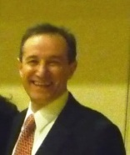
Vice President
Dr. Efthymios Daniskas MD 49 Erwin Park Rd Montclair, NJ 07042
(973) 509-7714 (Cell)
daniskas@aol.com

Secretary
James Mavrikidis 18 Overlook Terr.
West Orange, NJ 07052 973-325-9951 (Home)
973-234-5217 (Cell)
jmavrikidi@aol.com

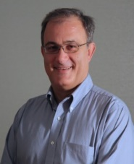
Treasurer Aristotle Massaras 304 Beach Street
Rockaway, NJ 07866
(973) 586-9578 (Home)
(201) 952-0320 (Cell)
tellymoo@gmail.com

Priest: Fr Seraphim Poulos Archimadritis
973-251-2920

Chapter Name: Wildwood #450 Established: December 25, 1973 Chapter City: North Wildwood, NJ Mailing Address:Same as below Meeting Night: 1st Wednesday Meeting Place: St Demetrios Church
321 St. Demetrios Ave N Wildwood, NJ 08260

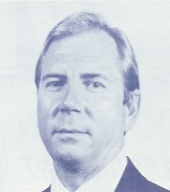
President
William A. Mitchell-Realtor 7800 Pacific Ave
Wildwood Crest, NJ 08260 (609) 522-4098 (Home)
(609) 465-7510 (Work)
(609) 425-4000 (Cell)
kirmizu@comcast.net

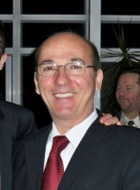
Vice President
Angelo Giouros
14 Cedar Meadow Drive
Cape May Court HS, NJ 08210 (609) 465-6605 (Home)
(609) 729-5511 (Work)
Email

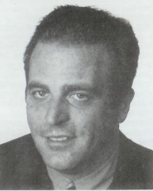
Secretary
Nick D Konides PDG 6012 Pacific Avenue Wildwood Crest, NJ 08260 (609) 368-5400 (Work)
(609) 425-0179 (Home)
ndk@snip.net

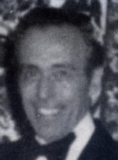
Treasurer James N Konides PO Box 266
Wildwood, NJ 08260
(609) 522-5400 (Work)
No email

Priest: Fr Steve Vlahos-Ahepan 609-522-0152
Chapter Name: Ramapo #453 Established: April 28, 1974 Chapter City: Wyckoff, NJ Meeting Night: 3rd Tuesday-7:30pm Meeting Place: St Nicholas Church
467 Grandview Ave
Wyckoff, NJ 07481
Website: www.ahepa453.org

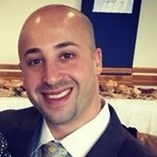
President
Jason Fink
65 Fairmount Avenue
Clifton, NJ 07011
(201) 206-7310 (Cell)
Jfink82@verizon.net

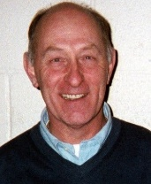
Vice President
Paul Goulet
140 Prospect Ave #11G Hackensack, NJ 07601
(201) 704-2018 (Cell)
Sannie1@optonline.net

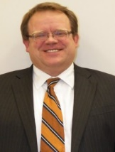
Secretary Charles Phlager 39 Island Avenue
Ramsey, NJ 07446
(201) 327-1807 (Cell)
pfasma5@yahoo.com

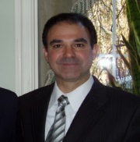
Treasurer
Basil Megariotis
94 Hamilton Avenue Elmwood Park, NJ 07407 (201) 794-7576 (Home)
bmegariotis@aol.com

Assistant Treasurer-John Tsadilas

Priest: Fr Bill Gikas 201-652-4774

Chapter Name: Ocean County #467 Established: April 27, 1978 Chapter City: Toms River, NJ Mailing Address: Same as below Meeting Night: Last Tuesday-7:30pm Meeting Place: St Barbara Church
2200 Church Rd Toms River, NJ 08753

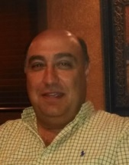
President
Savvas M Kyriacou 329 Jackson Mills Road Jackson, NJ 08527
(732) 833-0309 (Home)
(732) 492-0511 (Cell)
savvas1@optonline.net

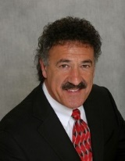
Vice President
Solon Karakoglou 1505 Princess Avenue
Brick, NJ 08724
(732) 860-1341 (Home)
solonk@aol.com

Secretary
Lou Larres
718 Arrow Drive Toms River, NJ 08753
(732) 286-7673 (Home)
(732) 608-3874 (Cell)
larres@verizon.net

Treasurer
Vassos Chrysanthou PDG+BOT 2212 Arvell Court
Toms River, NJ 08755 (732) 341-2918 (Home)
(732) 567-8952 (Cell)
vassos@prodigy.net

Priest: Fr Paul Pappas-Ahepan 732-255-5525
Chapter Name: Fairview #504 Established:
Chapter City: Fairview, NJ Mailing Address: Same as below Meeting Night: INACTIVE Meeting Place: Ascension Church
Anderson Ave. & Henry St. Fairview, NJ 07022

President
OPEN

Vice President

OPEN

Secretary
OPEN

Treasurer
OPEN

Priest: Fr Christos Pappas- 201-945-6448

Chapter Name: Garden State #517 Established: April 15, 1995 Chapter City: Holmdel, NJ Mailing Address: PO Box 735
Meeting Night: 3rdWednesday @ 8:00pm
Meeting Place: Kimisis Tis Theotokou
20 Hillcrest Road
Holmdel, NJ 07733

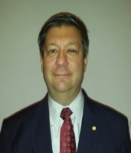
President
Demetri Orfanitopoulos 4 Devon Court
Holmdel, NJ 07733
(732) 977-3433(Cell)
Demetrio@comcast.net

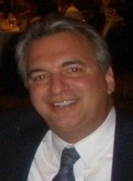
Vice President Steve Bontales 3 Pheasant Run
Holmdel, NJ 07733
(732) 672-7037 (Cell)
(732) 796-1006 (Work)
sbontales@comcast.net

Secretary
Tom Protentis
18 Old Manor Road Holmdel, NJ 07733
(732) 687-0545 (Cell)
(732) 687-0545 (Work)
thanasi@comcast.net

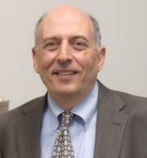
Treasurer
John Kalafatides
45 Blackhawk Court
Holmdel, NJ 07733
(732) 533-4936 (Cell)
jkalafatides@yahoo.com

Priest:
Chapter Name Liberty #532 Established: June 21, 2007 Chapter City: Clifton, NJ Mailing Address: Same as below Meeting Night: TBD
Meeting Place: St. George G.O. Church
818 Valley Rd
Clifton, NJ 07013

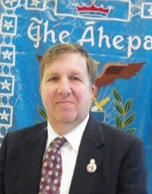
President
Spyro Panagakis 44 Deerfield Drive
Frankline, NJ 07416
973-827-4643 (H)
973-610-3899 (W)
spirop@earthlink.net40

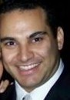
Vice President John Pilavas 40 Furman Dr.
Wayne, NJ 04470
(914) 882-2197 (Cell)
john.pilavas@gmail.com

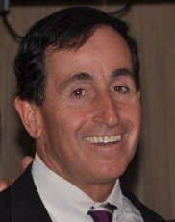
Secretary
Gus Haritos
25 Cresthill Ave.
Clifton, NJ 07012
(917) 742-5180 (H)
212-564-9666 (W)
gusharitos@gmail.com

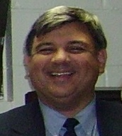
Treasurer
Ted Vittas 31Longport Rd
Wayne, NJ 07470-6434
(973) 839-4609 (H)
(908) 903-2052 (W)
vittas@optonline.net

Priest:

AHEPA Fifth District AHEPA Cancer Research Foundation, Inc.

Website: www.5thdistrictahepa-crf.org
Facebook Page: Fifth District AHEPA Cancer Research Foundation, Inc.

Foundation History
The Foundation was formed in October 1988, by the Fifth District Order of AHEPA to raise funds from its members and the general public for research grants. Shortly after, the Fifth District Daughters of Penelope came on board uniting the AHEPA Family behind a common cause of philanthropic support of cancer research.

The Foundation volunteers began their fundraising efforts in March of 1989. Armed with collection canisters thus inaugurated the humble beginnings of collecting donations to provide funding for cancer research.

Mission Statement:
Our Mission: The mission of the Foundation is to facilitate fundraising and to award grants to scientists and medical research institutions whose primary goal is to find a cure for cancer. The Fifth District AHEPA Cancer Research Foundation, Inc. is tax-exempt under 501 ( c ) (3) of the Internal Revenue Code. Contributions are deductible under the 170 (a) (2). We may accept employer matching grant donations.

2016-2017 Executive Board
Fifth District AHEPA Cancer Research Foundation, Inc.
Website: www.ahepafamily.org Founded 1992
Chairman
Antoinette Marousis-Zachariades 305 Worth Street
Brick, NJ 088724
(732) 458-8782 (Home)
(732) 539-4837 (Cell)
Email: ThiaNitsa@aol.com Chapter: Aulis #195
Vice Chairman Christos Prentzas 19 Locust Ave
Westmont, NJ 08108 Cell: 856~869-0892 Work:(609) 929-6053
christosprentzas@yahoo.com Chapter: Camden #69
Treasurer
Andrew C Zachariades, 305 Worth Street
Brick, NJ 08724
(856) 458-8782 (Home)
(908) 419-4053 (Cell)
a.zachariades@att.net Chapter: Hudson #108

Corresponding Secretary
Viveca Sulich
161 Johanson Ave
Hillsborough, NJ 08844
Home: 908-253-8685
Cell: 908-285-9512
Email: vivsulich@gmail.com Chapter : Thetys #229

Recording Secretary
Valerie Vittas
31 Longport Road
Wayne, NJ 07470
(973) 836-4609 (Home)
(973) 432-3425 (Cell)
valv@optonline.net

Board of Trustees Members

Georgette Boulegeris - Tethys #229 Penelope Capetan - Aphrodite #374 Ted Fanikos - Trenton #72 George Horiates - Camden #69 Alice Kartikis - Thetys #229
James Knicos - Trenton #72
Steve Lioumis, - Ocean County #467 Stathia Marousis - Aphrodite #374 John Mehos - Hudson #108
Lee Millas - Trenton #72
Thomas Sulich - Monroe #75
Demi Thomas - Agape #336
TedVittas - Liberty #532
Anna Zavros - Alexander # 250

George N.Petrakakis - Order of AHEPA District Governor

Isa Velez - Daughters of Penelope District Governor

Zenon Christodoulou - Order of AHEPA District Lt. Governor

Dina Fanikos - Daughters of Penelope District Lt. Governor

MEETING DATES:
Meeting Place Pines Manor, Edison, NJ

Mailing address:
5th District AHEPA
Cancer Research Foundation, Inc. PO Box 481
Edison, NJ 08818-0481

For Canisters contact Christos Prentzas

Supreme President Nikolas Apostolou Districts 3, 5, 25 n.apostolousop@gmail.com

Supreme Vice President Bill Poulos III
Supreme Vice President Districts 11, 12, 13, 21, 23 b.poulossop@gmail.com

Supreme Secretary Gregory Vourloumis Supreme Secretary Districts 1, 2, 16, 17, 20
g.vourloumissop@gmail.com

Supreme Treasurer Chris Tavantzis Supreme Treasurer Districts 4, 6, 8, 10, 22
c.tavantzissop@gmail.com

Supreme Governor Panagiotis Tsevdos Supreme Governor Districts 7, 9, 14, 24, 26
p.tsevdos@sonsofpericles.com

Supreme Athletic Director Paul Pavalkos
Supreme Athletic Director p.pavalkossop@gmail.com

SOP National Advisory Board Chairman
Sandy J. Papadopoulos Sopadvisor@AHEPA,org

SOP National Advisory Board Member
Ted Vittas PDG 31 Longport Rd
Wayne, NJ 07470-6434
(973) 513-3672 (Cell)
vittas@optonline.net

Patritha Chapter #317-Wyckoff President:
Arthur Kominos 98 Pulis Ave
Mahwah, NJ 07430
(201) 264-7718 (Cell)
arthur.kominos@gmail.com

Vice President: Christos Agrapidis Jersey City, NJ 07307 (201) 213-6959 (Cell)
agrapidis@hartford.edu

Secretary: Ryan Griffin 44 Glendale Rd
Park Ridge, NJ 07657
(201) 505-1455 (Cell)
Rgman1995@gmail.com

Treasurer:
Jake Paizis
500 Cedar Lane
Paramus, NJ 07652
(201) 693-1395 (Cell)
yankeefan8000@yahoo.com

Liason to District 5 Nikolas Apostolou 42 Long Hill Rd Oakland, NJ 07436
(201) 956-5737 (Cell)
n.apostolou@sonsofpericles.com

Kanaris Chapter #177-New Brunswick Liberty Chapter #330 – Clifton, NJ

President:
Nick Albanese 440 S Woods Rd
Hillsborough, NJ 08844
(908) 872-8938
nickalbanese.albanese@gmail.com

Vice President:
George Banis 6 Matthew Rd
Hillsborough, NJ 08844
908-281-5992
gbanis91@gmail.com

Secretary: Demetri Frangos 60 Liberty Dr
Dayton, NJ 08810
732-329-0451
greekgod92d@comcast.net

Treasurer:
Dionisios Bourodimos 11 Margaret Dr
Somerset, NJ 08873

Advisor: Nick Banis (908) 281-5992 (Home)
6 Matthew Rd
Hillsborough, NJ 08844 nbanis@cooksonelectronics.com

Carmine Albanese 440 South Weeds Rd
Hillsborough, NJ 08844
(908) 359-7253 (Home)
(908) 908-8008 (Work)
Carmine.albanese@spx.com
President: Daniel Souritzidis 3 Aldrin Drive
W Caldwell, NJ 07006 dsouritzidis@yahoo.com 862-219-2951

Vice President: Arthur Souritzidis 25 Llarkspur Lane
Clifton, NJ 07013 arthur.souritzidis@gmail.com 862-485-0454

Advisors:
Yianni Floropoulos Dimitri Tsounakis Spyro Katechis

NEW HORIZONS PARTY
New Jersey & Delaware

Term: 3 year
EXECUTIVE COMMITTEE:
Chairman
Lee Millas-PBOT (2015-2018)
62 Hamilton Road
Hamilton, NJ 08610
(609) 585-3137 (Home)
(609) 658-4372 (Cell)
Ljmillas@msn.com

Vice-Chairman:
Philip Vogis-PSG (2015-2018)
151 Fernwood Drive Old Tappan, NJ 07675 pvogis@verizon.net (201) 664-1534 (Home)
(551) 206-4372 (Cell)
pvogis@verizon.net

Secretary
Jim Knicos- (2015-2018)
797 Estates Blvd
Mererville, NJ 08610
(609) 587-4304 (Home)
(609)-915-3246 (Cell)
Kappa59@aol.com

Treasurer
Herbert P. Allen PDG (2015-2018)
226 Sheridan Road
Trenton, NJ 08619
(609) 587-3065 (Home)
(609) 306-9199 (Cell)
hpapdg@verizon.net

Board of Trustees, NJ/DE
- one year term, 2016-2017, a-George Petrakakis-Northern (732) 522-3797 (Cell)
- one year term. 2016-2017,
    - James W Karamanos-Central, (732) 234-5678 (Home)
- one year term-2016-2017,
    - Chris Diamandoukos-Southern (215) 260-7734 (Cell)

National Party Chairman
George Horiates Esq. PDG (2013-2016) 600 East Camden Avenue
Moorestown, NJ 08057
(856) 722-1933 (Home)
(856) 986-8972 (Cell)
gghoriates@aol.com

National Party Vice Chairman
Chris Mellas (2013-2016) 5531 Pebble Beach Lane Yorba Linda, CA 92886 (714)-693-1758 (Home)
(714)-813-6063 (Cell)
christomellas@aol.com

National Party Secretary
Asteris Fanikos Esq
31 Recklesstown Way
Chesterfield, NJ 08515
( 609)-291-5643 (Home)
( 609)-462-5634 (Cell)
afanikos@hotmail.com

National Party Treasurer

Daughters of Penelope District 5 Lodge Officers

Grand President
Jan Spanos-Sacramento, CA
Grand Vice President
Eva Jean Fomalont-Albuquerque, NM
Grand Secretary
Diane Petersen-Elk Grove, CA
Grand Treasurer
Aspa Kostopoulos-Ontario, Canada Grand Governor Zone I
Lili Respass, Worcester, MA
Grand Governor Zone II
Dorothea Williams, St Claire Shores, MI
Grand Governor Zone III
Kathy Papadimitropooulos, Aurora, CO
Grand Governor Zone IV Katherine Karafotias, Portland, OR Grand Governor Zone V
Celia Kachmarski—Calgary, Canada Grand Advisor Maids of Athena Kathy Zotos– Munster, Indiana

District #5 DOP District Lodge Officers
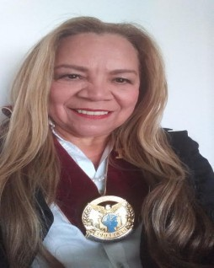
District Governor
Isa Velez, MD
7 N Columbus Blvd. Pier 5 Unit 247
Phila. PA 19106
T: 215-829-7260 M:609-230-9556
E: dbajfu@aol.com

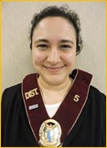
District Lt. Governor
Dina Fanikos
31 Recklesstown Way
Chesterfield, NJ 08515
M: 908-616-1214
E: dianfanikos@gmail.com

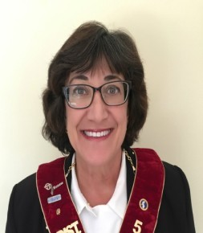
District Secretary
Joann Szela
6 Wilson Cove
Hillsborough, NJ 08844
T: 908-874-8311
E: jpszela@comcast.net

District Treasurer Demi Thomas
T: 201-652-0463
M: 201-925-6090
E: demithomas@gmail.com

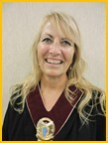
District Marshal Pattie Chrysostom M: 843-709-3389
E: pfc40@yahoo.com

District DOP Advisor & District DOPs website:

Karen Knicos
32 Terrapin Ln
Hamilton, NJ 08619 M:732-713-5154
E: karenknicos@gmail.com

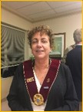
www.5thdistrictdaughtersofpenelope.com MOA Advisor
Eleni Parlapanides PDG
478 Mountainview Drive North Plainfield, NJ 07063 908-612-5044 (Cell)
Mitilini12@aol.com

Daughters of Penelope –PDGs

DAUGHTERS OF PENELOPE-PDGs:

Past District Governors
1948-1950 Julia Caravoulias (2 terms)* Icarius #48, Jersey City
1950-1951 Helen Millas* Altes #163, Trenton
1951-1952 Maria Tsucalas* Icarius #48, Jersey City 1952-1953 Mary Diamond Janis* Kronos #188, Clifton 1953-1954 Irene Kyriakakis* Kronos #188, Clifton
1954-1955 Lillian Manetas* Altes #163, Trenton 1955-1956 Kiki Sareotes* Aulis #195, Asbury Park
1956-1957 Helen Heleotis Murphy Aulis #195, Asbury Park
1957-1958 Joanne Nicas Georgeson* Ogygia #207, Perth Amboy
1958-1959 Helen Gianakopoulos Constantapoulos* Altes
#163, Trenton
1959-1960 Pauline Zavakos* Nike #230, Camden
1960-1961 Elizabeth Saridakis Harris* Cleo #240, Atlantic City
1961-1962 Betty Colonias Diamond* Ion #286, Elizabeth
1962-1964 Frances Yack (2 terms)* Ion #286, Elizabeth
1964-1965 Mary Dertouzos* Altes #163, Trenton
1965-1966 Julia Sapounakis* Nike #230, Camden
1966-1968 Angelique “Kiki” Lampros (2 terms)
Amphitryon #173, Newark
1968-1969 Nora Lemperes Sellick Nike #230, Cherry Hill 1969 Annette Pantel Cadmus #165, Paterson
1969-1972 Eva Jean Fomalont (3 terms) Aulis #195, Asbury Park
1972-1974 Betty Haralambidis (2 terms)* Cadmus #165, Paterson
1974-1975 Despina Veloudos Cadmus #165, Paterson
1975-1976 Barbara Petridis* Kronos #188, Clifton
1976-1978 Irene Wilcox (2 terms)* Amphitryon #173, Newark
1978-1979 Angelina Flamos* Amphitryon #173, Newark
1979-1980 Lillian Demitry* Altes #163, Trenton
1980-1981 Penelope Capetan Tethys #229, New Brunswick
1981-1982 Elpis Hope Demitry Altes #163, Trenton 1982-1983 Helen G. Mougakos Nemesis #307, Vineland 1983-1984 Lillian Boyadjis* Alexander #250, Dover
1984 Agnes Brougas* Kronos #188, Clifton
1984-1985 Mary Boyadjis* Alexander #250, Dover
1985-1987 Marion Economo (2 terms) Alexander #250, Dover
1987-1988 Evelyn Vardakis Icarius #48, Jersey City 1988-1989 Freda Sakas Alexander #250, Dover
1989-1990 Mary Boyadjis* Alexander #250, Dover
1990-1991 Evellyn Tsiadis Tethys #229, New Brunswick
1991-1992 Helen Mitsakos Eleni #308, Fort Lee
1992-1993 Theognosia Michaels* Eleni #308, Fort Lee 1993-1994 Vera Andresakes Zephyr #259, Orange
1994-1995 Johanna Lioumis Aphrodite #374, Toms River 1995-1996 Georgette Boulegeris Tethys #229, New Brunswick
1996-1997 Sophia Fotakos Xanthus #149, Wilmington 1997-1998 Cathy N. Politis Spina Icarius #48, Jersey City 1998-1999 Anamaria Anagnostou Xanthus #149, Wilmington
1999-2000 Martina Harris Nike #230, Cherry Hill 2000-2001 Karen Pascal Aulis #195, Asbury Park
2001-2002 Stathia Marousis Aphrodite #374, Toms River 2002-2003 Pauline Ploussiou Tethys #229, New Brunswick
2003-2004 Joyce Allen Altes #163, Trenton
2004-2005 Patricia Vlahos Aulis #195, Asbury Park 2005-2007 Antoinette Marousis-Zacharaides (2 terms) Aphrodite #374, Toms River
2007-2009 Demi Thomas (2 terms) Agape #336, Wyckoff 2009-2010 Robin Papagiannas Aulis #195, Asbury Park 2010-2012 Karen Marousis (2 terms) Aphrodite #374, Toms River
2012-2013 Eleni Parlapanides Tethys #229, New Brunswick
2013-2014 Marcella Calagias Altes #163, Trenton
2014-2015 Anna Zavros Alexander #250, Randolph
2015-2016 Karen Knicos Altes #163, Trenton

Vasiliki Koukounaras 117 Park Ave
West Caldwell, NJ T: 973-403-8482
E: vkoukounaras@aol.com
Vice President
Christina Polychronis-Barker 2787 JFK Blvd Unit 505 Jersey City, NJ 07306
T: 201-798-6954
E: cpolychronis@hotmail.com
Recording/Cor. Secretary Maria Karras
45 Sycamore Road Jersey City, NJ 07305 Tel: 201-435-8458
Treasurer
Anna Evangelista 3336 Kennedy Blvd Jersey City, NJ 07307 Tel: 201-653-2029
XANTHUS #149, WILMINGTON, DE
President Gale Kostas
3 David Court
Wilmington, DE 19803
Tel: 302-764-7278
Vice President Lauren Diamond 27 Country Gate Rd
Wilmington, DE 19810
T: 302-477-0250
E: laurendiamond16@gmail.com
Recording Secretary Nickoletta Klezaras 22 Doncaster Road
New Castle, DE 19720 Tel: 302-322-0430
Treasurer Lynn Kostas 3 David Ct
Wilmington, DE 19803
T: 302-593-4159
E: lynkostas@gmail.com
Maria E. Brenna 2 Mansfield Rd
Trenton, NJ 08628
T: 609-577-7057
E: brennacellini2365@verizon.net Vice President
Sonia Huber
19 Mill Bend Rd Hamilton Sq, NJ 08690 T: 609-890-7569
E: atalker@aol.com
Recording Secretary Toula Arland
41 Glen Stewart Dr Ewing, NJ 08618
T: 609-883-5938
E: arlatoot@aol.com Treasurer
Jill Belviso
5 Brian Dr
Hamilton, NJ 08619
T: 609-838-2431
E: Jill1961@gmail.com
Corresponding Secretary Jane Allen
226 Sheridan Road
Hamilton, NJ 08619
Tel: 609-695-4033
CADMUS #165, PARAMUS, NJ (INACTIVE) AMPHYTRION/ZEPHYR #701, Roseland, NJ
President Irene Wilcox
60 Watson Ave Apt 2-J Elizabeth, NJ 07202
Tel: 908-352-1290
Vice President Barbara Zois
287 Martin Luther King Blvd Newark, NJ 07102
Recording Secretary Mary L. Marolakos 600 Parker Street
Newark, NJ 07104
Tel: 973-482-4673
Treasurer Kathryn Vasiliou 17 Elmwood Ave.
Bloomfield, NJ 07003
Tel: 973-429-8577

Daughters of Penelope Chapter Officers

KRONOS #188, CLIFTON, NJ
President Alexandra Kleiner 7 Craig Ct.
Totowa, NJ 07512
T: 973-785-1069
E: Skleiner01@optimum.net
Vice President Lucinda Kallimanis 254 Maple Hill Dr
Hackensack, NJ 07601
T: 201-933-1643
Recording Secretary Darla Matsakis
42 Sunset Rd
Bloomingdale, NJ 07403
T: 973-283-0502
E: mrsmathsakis@optonline.net Treasurer
Maria D’Accampo
320 Franklin Ave
Belleville, NJ 07109
T: 973-759-2515
AULIS #195, ASBURY PARK, NJ
President Patty Vlahos
95 Secretariat Ct Tinton Falls, NJ 07724 T : 732-542-7195
patala@aol.com
Vice President Penelope Gabriel 10 Eunice Terr
W. Long Branch, NJ 07764 T: 732-229-8274
E: tobessie@aol.com
Recording Secretary Mary Ann Iliopoulos 68 Comanche Dr
Oceanport, NJ 07757 Treasurer
Maria Conery
36 Peachtree Road
Oakhurst, NJ 07755
Tel: 732-229-4454
Corresponding Secretary Denise Parlamas
334 Roosevelt Ave
Oakhurst, NJ 07755
T: 732-531-7321
E: supermoma7@aol.com
TETHYS #229, NEW BRUNSWICK, NJ
President
Georgette Boulegeris 18 Heatherwood Ln
Bedminster, NJ 07921
T: 908-719-8701
E: giggiette@aol.com
Vice President Viveca Sulich
161 Johnson Avenue
Hillsborough, NJ 08844
Tel: 908-253-8685
Email: vivsulich@verizon.net Recording Secretary
Irene Frangos
6 Liberty Dr,
Dayton, NJ 08810
Tel: 732-329-0451
Alethia5@Comcast.net Treasurer
Katina Kehayas
950 Hoover Dr.
N. Brunswick NJ 08902 Tel: 732-297-2631 Kkehayas@rocketmail.com
NIKE #230, CHERRY HILL, NJ
President
Stacey Chryssofos 556 Norwood Rd
Mt. Laurel, NJ 08054 T: 856-816-7456
E:schryssofos@comcast.net Vice president
Melissa Giambanis
1410 Autumn Lane Cherry Hill, NJ 08002 Tel: 856-429-6980
Recording Secretary Maria Pappas
1930 Kark Rd
Haines Port, NJ 08036 T: 856-979-2766
E: mariapappas@dla.mil Treasurer
Joan Ramoundos
14 Ticonderoga Rd
Clementon, NJ 08021
T: 856-783-5170
E:joan.ramoundos@comcast.net Corresponding Secretary

Daughters of Penelope Chapter Officers

ALEXANDER #250, RANDOLPH, NJ
President Athena Borzeka 3604 Scenic Ct
Denville, NJ 07834
T: 201-213-2293
E: athena2553@aol.com
Vice President Eleni Peterson
16 Glenwood Ave
Randolph, NJ 07869
T: 973-214-3488
E: rotsidese!@gmail.com
Recording Secretary Julia Ioannou
4 Lancer Terr
Randolph, NJ 07869
T: 201-602-1359
E: jioannou18@aol.com
Corresponding Secretary Chrysanthe Borzeka
111 W. Hanover Ave Randolph, NJ 07869
T: 973-933-2601
E: jcborzeka2@aol.com
Treasurer
Joan Ramoundos 14 Ticonderoga Rd
Clementon, NJ 08021
T: 856-783-5170
E:joan.ramoundos@comcast.net
Treasurer Helen Savvides
15 Woods End Road West Orange, NJ 07052 Tel: 973-731-7392
ELENI #308, FORT LEE, NJ (INACTIVE) AGAPE #336, WYCKOFF, NJ
President
Effie Stratis-TeFarikes 23 Alpine Dr
Wayne, NJ 07470
O: 201-459-2849
M: 201-306-2904
E: estratis1@yahoo.com
Vice President Thalia Kalamarides 7 Greene St
Mahwah, NJ 07430
T: 201-847-8071
E:thaliacleo@aol.com
Recording Secretary Valerie Vittas
31 Longport Rd
Wayne, NJ 07470
T: 973-839-4609
E: valv@optonline.com
Treasurer Alice Eliades 8 Kirk Terr
Wayne, NJ 07470
T: 973-956-7681
E: adelia174@hotmail.com
APHRODITE #374, TOMS RIVER, NJ
President
Karen Marousis, PDG 206 Sunrise St
Brick, NJ 08724
M: 732-691-0161
kalexis117@gmail.com
Vice President Arelena Mitchell
204 Rt. 9 – North Main St Forked River, NJ 08731 M: 609-693-4824
Recording Secretary Roxann Palestis
7 Eldorado Dr
Lakewood, NJ 08701
M: 732-804-0683
Corresponding Secretary Matina Larres
718 Arrow Dr
Toms River, NJ 08753 M: 732-608-3172
lamia08753@verizon.net
Treasurer Stathia Marousis 613 Hill Drive
Brick, NJ 08724
Tel: 732-458-7197
Corresponding Secretary Evelyn Staknys
17 Greenfield Court Toms River, NJ 08757 Tel: 732-349-4749

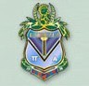
Grand President Maids
Tria Charnas moagrandpresident@gmail.com

Grand Vice President
Effie Sapuridis

Grand Secretary
Sophia Shakolas

Grand Treasurer
Tatiana Tsaprailis

Grand Governor
Gabriella Papatzimas

Grand Advisor Kathy Zotos
Terpsichore Chapter #236-Wyckoff

President Christina Eliades 8 Kirk Ter
Wayne, NJ 07470
(973) 595-8512 (Home)
Wayne, NJ 07470 Christina.eliades@gmail.com

Vice President
Alexandra Kominos

Secretary Christina Vittas 31 Longport Rd
Wayne, NJ 07470-6434
(973) 839-4609 (Home)
cvittas13@gmail.com

Treasurer
Alexis Phili

Members: Georgia Agrapidis Ariana Cicatiello Gabriela Can

Advisors: Valerie Vittas Alice Eliades Zoe_Kominos

CIVIC AFFAIRS COMMITTEE: KNOW YOUR REPRESENTATIVES
Zenon Christodoulou, VP of Civic Responsibility

NEW JERSEY
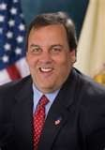
Governor (R)
Chris Christie (609) 292-6000

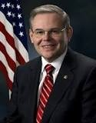
US Senator Bob Menendez (D) Brother Ahepan Chapter #287 (202) 224-4744

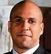
US Senator Cory Booker (D) (856) 338-8922

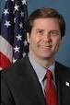
Congressman Donald Norcross D-1 (8 56) 427-7000

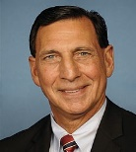
Congressman Frank LoBiondo D-2 (609) 625-5008

Congressman Tom MacArthur D -3 (856) 267-51

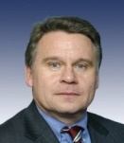
Congressman Chris Smith D-4 (609) 585-7878

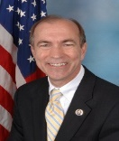
Congressman Scott Garrett (R)
D-5 BrotherAhepan201-444-5454 Chapter #453

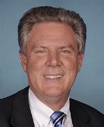
Congressman Frank Pallone Jr D-6 Brother Ahepan
(732) 571-1140 Chapter #287

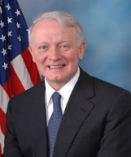
Congressman Leonard Lance D-7 (908) 518-7733
Congressman Albio Sires D-8 (201) 309-0301

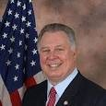
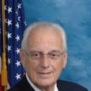
Congressman Bill Pascrell D-9 (201) 935-2248

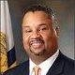
Congressman Danold Payne Jr. D-10

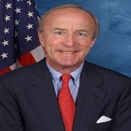
Rodney Frelinghuysen D-11 Brother Ahepan (973) 984-0711

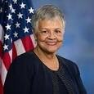
Congresswoman
Bonnie Watson Coleman D-12 (609) 883-0026

DELAWARE:
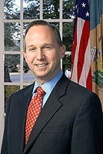
Governor-Jack Markell (302) 577-3210

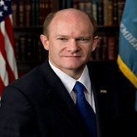
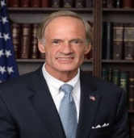
US Senator Chris Coons (302) 573-6345

US Senator Tom Carper (302) 674-3308

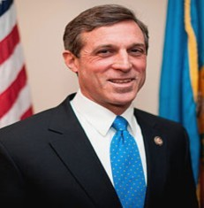
Congressman John Carney (302) 691-7333

DIRECTIONS TO CHAPTERS:

- EUREKA #52 . . . American Legion Hellenic Post #440. 1025 Greeley Avenue N. Union NJ 07083. Take the Garden State Pkway south, get off exit 140 and take Route 22 West for 2 miles, immediately after Charlie Browns make a right to the building on your right hand,

- ALEXANDER HAMILTON #54. . . St. Athanasios
Church. 51 Paramus Rd Paramus, N.J. Take the Turnpike to the Garden State Parkway to exit 160. Proceed to traffic light and turn left onto Passaic Ave. When you cross over Rte..4, Passaic Ave. becomes Paramus Rd. The church will be on your left. You will see it as soon as you go over Rte. 4.

- CAMDEN #69 . . . St. Thomas Church. . .615 Mercer St., Cherry Hill, N.J. N.J. Tpke. to exit 4, bear right to 73 North then past one light to get on 295 South. Take first exit 34B to 70 West - Cherry Hill. Go about 2.5 miles and turn right on Mercer Street, the last street before light at Haddonfield Road & Garden State Plaza Follow Mercer Street to St. Thomas on your left.

- TRENTON #72. . . AHEPA HALL 340 William St.,
Trenton, N.J. (609) 396-HALL . . . From New Jersey Tpke: Take Exit 7A to 195 West. Take Exit 2, South Broad Street- 206south (approx. 2 miles) to PAT'S DINER on the right (Stanton St.) Make right onto Stanton and go down to William St. and turn left. AHEPA HALL is on your imme• diate right.

- MONROE #75 . . . St. George Church. . . 1101 River Road, Piscataway, N.J. (732) 463-1642 From 287 N. take Exit 5, Highland Park, Boundbrook. Turn left onto River Rd. After the traffic light proceed about a quarter of a mile, the Church is on your left. FROM THE NEW JER•SEY TPKE., Take Exit 9, Rte. 18, New Brunswick. After the toll plaza, make an immediate right (New Brunswick) onto Rte. 18 North. Remain on Rte. 18 to River Rd. exit make a right, pass through one traffic light, proceed about a quarter of a mile, the Church will be on your right.

- WILMINGTON #95 . . . Holy Trinity Church. . . 808 North Broom St., Wilmington, DE. Take N.J. Turnpike south to Exit 2. After toll go to end of ramp and make left onto Rte. 322. Take 322 to the Commodore Barry Bridge, after bridge take Rte. 95 South to Wilmington. Get off 95 South at the DELAWARE AVE. Exit, go to the end (Delaware Ave.) make right and stay over to your left. Go about four blocks and turn left onto N. Broom St., proceed 2 blocks and Church is on the left. Also NJT south to exit 1, go over the bridge, take 95north to exit 7 Route 52 North to N Broom St and make a left.
- HUDSON #108 . . . Evangelismos Church. . . 661 Montgomery St., Jersey City, N.J. . . . From North and South - N.J. Tpke. to Exit 14C. After toll, follow signs to Columbus Drive go past traffic light & bear left to U turn Proceed to light and turn right onto Montgomery . Continue on Montgomery until you get to the Church which is on the left on the corner of Montgomery St. and Summit Avenues.

- SOUTH JERSEY #162. . . St Anthony's Church. . .430 \/ Vest V\lheat Road, Vineland, N.J. . . From North, take turnpike South to Exit 7, continue to 206 South and then onto
54 South to the end. You will pass two traffic lights and railroad tracks. The Church will be on your right. . . From Delaware Mem. Bridge, take Exit on right for Rte. 40. Take 40 East to 47 South. Continue and make a left on V\lheat Road, Pass West Ave. and Church will be on your left.

- THOMAS JEFFERSON #280. . . Holy Trinity Church… 250 Gallows Hill Rd, Westfield, N.J.. . . . From North and South take Garden State Parkway to the RT-28 exit- EXIT 137- toward Roselle Pk/Cranford. Merge onto NJ-28/North Ave E toward Cranford. Turn Right onto Cedar St. Turn slight right onto Brookside Pl. Turn left onto Gallows Hill Rd. Take to the end at 250 Gallows Hill Rd or Exit 138 turn left on Blvd go 7 lights make a left on East Broad to Gallows Rd and make a left to the Church.

- BERGEN KNIGHTS #285 . . . St. John The Theologian Cathedral. . .353 E. Clinton Ave., Tenafly, N.J. Take 1-95 North until it merges with 1-80, follow 1-80 to Geo. Washington bridge (stay on right following signs for local lanes. Take 9W Exit before bridge. Take 9W to E. Clinton Ave. Make left onto E. Clinton, proceed to the top of the hill until you see Church on right.

- THOMAS EDISON #287 . . . St. George Church. . . 1155
W. Park Ave. . . . Ocean Township, N.J. . Take Garden State Parkway to Exit 105 at the traffic light make a right. Continue to the third traffic light and make a left that is W Park Avenue, continue for appro 1 mile, go over Route 18 immediately the church is on your left hand

- MORRIS COUNTY #300 . . . St. Andrew's Church, Sussex Tpke. Randolph, N.J. . . From the East take Rte. 80 West to 287 South exit 39 to 10 West. Go approx 10 miles until you see the sign Ironia & Chester, exist on your right hand, follow the sign Ironia & Chester, cross Route 10 and continue two traffic lights, That is Sussex Trunpike make a right go 200 feet the church is on your right hand.

DIRECTIONS TO CHAPTERS:

- EAGLE ROCK #375 . . . Ss.Nicholas, Constantine and Helen Church, 80 Laurel Avenue, Roseland, N.J. From North or South, take Garden state Parkway to Exit 145, Rte. 280 \/Vest (The Oranges) to Exit 6B. Go 400 feet, the church is on your right.
Ahepachapter375@gmail.com

- WILDWOOD BY THE SEA #450 . . .
Take Garden State Parkway South to Wildwood. The Chapter President of #450 always lets us know at what restaurant the meeting will be held.

- RAMAPO #453 . . .St. Nicholas Church, 467 Grandview Ave., Wyckoff, N.J. . . From Garden State Pkwy north take Exit 160, proceed to light and turn left onto Passaic Ave. Go about a quarter of a mile over Rte. 4, at the end of overpass make a right and go down ramp to Rte. 4 west - stay to right and get onto Rte. 208 North - go for about four miles to Grandview Ave. Exit. Go to stop sign and turn left, go about 200 ft. and turn left onto St. Nicholas Church driveway.

- OCEAN COUNTY #467 . . .St. Barbara Church, 2200
Church Rd., Toms River, N.J. . . From North take the Garden State Pkwy. South to Exit 88; after toll proceed to traffic light and turn left onto Rte. 70 East towards Lakewood. Go to the first traffic light and turn right onto Shorrock Rd. Go to end of Shorrock Rd. and turn left onto Beaverson Blvd. Proceed to second light and turn right onto Church Rd. (after Exxon station). Go about a half mile and Church is on right. From the South, take G.S.P. North to Exit 83 - after Exit, continue North on Rte. 9, go to the third traffic light and turn right onto Church Rd. Proceed about two and one-half miles. Church is on your left. From Trenton area take 195 East to Exit 16 "Great Adventure". Take Rte. 537 to Rte. 571 East and turn left onto Rte. 9, pass the blinking light and turn right at the next light (Church Rd.). Proceed two and one-half miles and Church is on the left.

- GARDEN STATE #517 . . Kimisis Church, 20 Hillcrest Rd., Holmdel, N.J. . . Garden State Pkwy. To Exit 117 "Hazlet, Keyport, Rtes. 35 & 36". After toll, bear right onto Rte. 35 South. Proceed to first traffic light (Shore Point Inn) and turn right onto Holmdel Rd. Proceed until you cross over G.S.P., after which you will make an immedi•ate right turn onto Hillcrest Rd. Church is 200 yards on right.
- LIBERTY #532…St George Church 818 Valley Road, Clifton, NJ Garden State Parkway south to exit 154, after the toll stay on the left lane to enter route 46 west. Go approx 1 mile and take the Valley Road exit stay on the right till you get to the stop sign. Turn right and go approx 200 feet the church is on your left hand.
Garden State Parkway north to exit 153, route 3 north when you merge onto route 46 west get off on Valley Road and follow instructions above.

- METROPOLIS OF NJ, take the Garden State Parkway south to exit 135, follow the signs bear right Westfield/Central Ave for approx 2 miles, make a right on the traffic light East Grove Street, go 2 blocks the Metropolis Building is on your right hand 215 East Grove Street, Westfield NJ 908-301-0500.

- ST BASIL ACADEMY Garrison, NY, take PIP North to the Bear Mountain Bridge, cross the bridge and make a left on to 9D north, continue to the town of Garrison, St Basil Academy is on your left hand as you head north.
845-424-3500, Fr Costas Setaras, Office Manager Ms Roseanne Roberts rroberts@goarch.org

- ODYSSEY CHARTER SCHOOL, Wilmington, DE,
302-994-6490
Principal:

ODYSSEY UPPER BLDG-302-655-5760
George Righos 302-655-5760

- PINES MANOR-Edison, NJ take NJ Turnpike Exit 10 to 287 North go to Exit 2B and take Route 27 South, at the exit bare right continue for half a mile to Pines Manor on your right hand, or GSP to Exit 131 take Route 27 South to Pines Manor,

- RARITAN CHAPTER #288 St Demetrios Church, 41-47 Wisteria Street, Perth Amboy, NJ 08861 Garden State Parkway:
Take Exit 125 to Rt. 35 North to Smith Street. Make a right turn onto Smith Street. Follow straight to High Street. Make a right turn onto High Street and go to the end. Make a right turn onto Sadowski Parkway. Go one block, church is ion your right.

AHEPA BUSINESS NETWORK
This page was developed to be used as a tool for Brothers in their efforts to network their businesses and to promote one another. It is also available as a quick contact list. If you have an interest in placing your business in the next issue, please contact District Governor Brother Asteris Fanikos.

BUSINESSES:

Acropolis Hotel Wildwood, NJ Nick Konides 609-522-5400

Alpha Cards Philadelphia, PA Lazaros Kalemis 866-253-2227

Aktina FM 91.5 Radio
Elena Marouletti 718-545-1151
23-50 27th Street
PO Box 5869
Astoria, NY 11105

Apollo Diner Neptune, NJ Ernie Tsaptsinos 732-938-4567

Athenian Private Client Group
Hackensack, NJ Spiros Vassilakos 201-227-4722

Bacari Grill
Washington Township, NJ John Amoratis
201-358-6330

Bill’s Flower Market New York, NY William Nikolis
212-889-8154

Bill Parlamis
General Construction Co 732-888-7880 Office
917-617-4087 Mobile

Carmona Bolen, Home for Funerals
Toms River, NJ 732-349-1922
Chester, Ploussas, Lisewsky Partenrship LLP
Planning, Architecture, Engineering 732-566-0297

Cosmos FM 91.5 Radio Ioanna Gianopoulou 718-204-8900
23-18 29th Street
Astoria, NY 11105

Crossroads Realty, Inc.
Toms River, NJ Antonis Verikios 732-244-4900

Dairy Queen Manasquan, NJ Constantinou Family 732-223-2199

Demetrios G. Melis and D. Melis, Attorneys
New York, NY 212-279-6818

Ernst & Young Philadelphia, PA Chris Diamantoukos 215-448-5126

Euclid Financial Group Washington, D.C. Andreas Pericles
202-822-2134

FBE Limited
New York, NY Andreas Zachariades 212-266-8263

Garden State Diner
Wrightstown, NJ
Zach Rotsides; 609-723-5625
General Contractors Stelios Kodopidis 609-516-2973

George Horiates Esq
Pennsauken, NJ 856-665-2085

George N. Pappas, CPA georgepappascpa@verizon.net 856-482-9200

George N. Petrakakis Weichert Referral Agent gpetrakakis@outlook.com 732-522-3797 Mobile

Greek Cultural Center 26-80 30th Street Astoria, NY
718-726-7329

GREEK SPIRIT TV
Owner Mr. George Burlotos “Touches Many Lives” Sundays 8-10pm
Mondays and Wednesdays 9pm at Stockton College
609-457-1742 Mobile

Hellenic News of America
Paul Kotrostios 610-446-1463
610-202-4465 Mobile

Hellas Radio on the Internet
www.hellasfm.us
Mr Demetris Filippidis 718-707-3120

JTK Entertainment - Manny
732-826-9245

BUSINESSES:

Lock-N-Load Investigations George N. Petrakakis Licensed Private Investigator gpetrakakis@outlook.com 732-522-3797 Mobile

Louis Karagias Esq
732-914-9005 Mobile
732-600-3864
Cherry Hill, NJ

Metropolis of New Jersey 215 E Grove Street Westfield, NJ 07090-1656
908-301-0500 Office
908-301-1397 Fax

NEO Magazine Demetrios Rhompotis 718-554-0308
info@neomagazine.com
Nicholas Pools Toms River, NJ Sotiris Sergiou 732-505-0404

Oceanos Restaurant
Fair Lawn, NJ Peter Panteleakis 201-796-0546

Papian Enterprises
Ocean, NJ
Savas C. Tsivicos 732-775-3700

Paskas Funeral Service
Union, NJ Michael Paskas 973-467-1882

Paulson Investments
Sea Girt, NJ Steve Xanthacos 888-462-6444

Pool Town
Howell, NJ
Vassos Chrysanthou 732-901-9071
Spa Department - Lou Larres 732-901-9071

S.B.N. Enterprises Toms River, NJ Chris Karamanos 732-244-7200

Seasons Fine Catering Washington Township, NJ Jimmy or Carl
201-664-6141

Stavros Theodorou Orchestra Greek Music and Entertainment 917-687-7581

St. Andrew Eastern Orthodox Law Enforcement Federation of New Jersey
George N. Petrakakis President
732-522-3797 Mobile

St. Basil’s Academy
Garrison NY
Fr Costa Sitaras 845-424-3500

The Forge Inn
Woodbridge, NJ
/ 2445 / 2446
Jimmy or George

The National Herald 37-10 30th Street Astoria, NY
Veta Diamataris - Papadopoulou 718-784-5255

Townsquare Restaurant
Wharton, NJ Costa Sedereas 973-366-7309

Venitian Fine Catering
Garfield, NJ 973-546-2250
Jimmy, Peter or Carl

White Star Tours
Reading PA Gust Kraras 800-437-2323

----------------------------------------------------------

Ambassador of Greece
Washington DC 202-939-1306

Council General of Cyprus
212-223-4500

Council General of Greece
Mr Yiorgos Illiopoulos 212-988-5500

----------------------------------------------------------

Hellenic Societies:

Hellenic Federation of NJ
info@hellenicfederationnj.com

Federation of Hellenic Society of Greater NY
Hellenicsocieties@yahoo.com

Listing of All Member Organizations of the Hellenic Federation of NJ http://www.hellenicfederationnj.org/members.html

------------------------------------------------------------

Miscellaneous
EventBrite https://www.eventbrite.com

The Greek Orthodox Archdiocese, The Metropolis of NJ, The Federation of Hellenic American Organizations of NJ, The Cyprus
Appointed Liaisons to Hellenic Organizations
Children’s Fund and the National Cyprus and
Hellenic Affairs Committee,
Savas C. Tsivicos PDG 524 Green Grove Road Wayside, NJ 07712
(732) 493-9351 (Home)
(732) 229-1532 (Cell)
tsivikos@aol.com

St. Basils Academy Evelyn Tsiadis, PGP DOP 911 Margaret Court
South Plainfield, NJ 07080 908-222-0013 home
EvellynT@aol.com

Pan Icarian Brotherhood and President of the Philadelphia Federation of Hellenic Societies George G. Horiates PDG
600 East Camden Ave Moorestown, NJ 08057
(856) 722-1933 (Home)
(856) 986-8972 (Work)
Email: gghoriates@aol.com

Order of St. Andrew the Apostle
John Mehos PSG 56 Greenville Ave
Jersey City, NJ 07305 (201) 333-1081
j.mehos@verizon.net

Hermes Expo & Hellenic News
Paul Kotrotsios-Founder 26 West Chester Pike Havertown, PA 19083
610-446-1463 (Office)
610-202-4465 (Cell)
610-446-3189 (Fax)

Hellenic Relief Foundation, Inc.
PO Box 735
Mineola, NY 11501
347-201-1821
Philip Vogis PSG-Region 3 Board of Directors

If you are active in another organization and would like to serve as a liaison between AHEPA and your organization, contact the District Governor Asteris Fanikos for consideration.

Media Resources

Greek News Online
http://www.greeknewsonline.com/
The Courier Post – Camden
http://www.courierpostonline.com

The National Herald
http://www.thenationalherald.com/
The Daily Record – Parsippany
http://www.dailyrecord.com

The Greek Reporter
http://usa.greekreporter.com/
NJ Herald – Sussex County
http://www.njherald.com

Greek Newspapers, Magazines, and Mass Media Publishers
http://www.hri.org/nodes/grmm.html
MyCentralJersey.com – Middlesex County
http://www.mycentraljersey.com

Cosmos FM Hellenic Public Radio
http://www.cosmosfm.org/
News 12
http://newjersey.news12.com

Hellas FM Radio
http://tunein.com/radio/Hellas-FM-s114305/
The Star Ledger
http://www.nj.com

HNA
https://hellenicnews.com/
Asbury Park Press
http://www.app.com

Greek Spirit TV
http://www.greekspirittv.com/

Stelio, the photographer Cosmos Philly http://cosmosphilly.com/
Listing of Newspapers, Magazines, and College Newspapers in NJ http://www.usnpl.com/njnews.php
Listing of TV Stations in NJ
http://www.stationindex.com/tv/by-state/NJ

AKTINA FM
http://www.aktina.org/
Listing of Cable Companies in NJ
http://www.cablenj.org/AboutUs/CableProviders.asp

Orthodox Observer observer@goarch.org http://www.observer.goarch.org
Listing of Radio Stations in NJ https://en.wikipedia.org/wiki/ List_of_radio_stations_in_New_Jersey

Amboy Guardian
http://www.amboyguardian.com/
Listing of College Radio Stations in NJ
http://www.a2zcolleges.com/college_radio/newjersey.html

The Trentonian
http://www.trentonian.com/
Listing of NJ Online Newspaper
http://www.onlinenewspapers.com/usstate/usnewjer.htm

Bergen Record
http://www.northjersey.com
Listing of Diners in NJ
http://www.njdiners.com/

Herald News
http://www.northjersey.com

AHEPA FAMILY Resources
AHEPA D5 Email List Serv
ahepad5@hec.greece.org
DOP D5 Email List Serv
d-o-p-dist5@hec.greece.org
AHEPA Voice
Phil Vogis, pvogis@verizon.net Lee Millas ljmillas@msn.com Ted Vittas, vittas@optonline.net
The AHEPAN Magazine ahepa@ahepa.org basil@ahepa.org
AHEPA District 5 Facebook Page https://www.facebook.com/pages/Ahepa-District- 5/122057327878461
Daughters of Penelope District 5 Webpage
http://www.5thdistrictdaughtersofpenelope.com/
AHEPA District Governors
http://ahepa.org/ahepa/DistrictGovernors.html
AHEPA Twitter Account

Middlesex County Public Access Channels
Perth Amboy -PATV
(Ch. 34): davegarb@paps.net
Woodbridge Public Access Channel (Ch. 35): tv35@twp.woodbridge.nj.us
So Amboy Public Access Channel
events@southamboynj.gov
Sayreville Public Access Channel
saytv@hotmail.com
Old Bridge Public Access Channel (Now Ch. 15)
tv14@oldbridge.com
Metuchen Public Access Channel
metv.metuchennj@verizon.net
Perth Amboy PA Local TV mbonilla@perthamboynj.org

Online Newspapers/Community Boards
News12.com: http://www.news12.com/index.jsp
(click on 'What's Going On' on top, then "Post an Event")
NJ.com: http://www.nj.com/events/results/index.ssf

Home News Tribune: http://search.mycentraljersey.com/localevents/ (DO NOT USE ALL CAPS) Suzanne Russell: www.srussell@mycentraljersey.com
732-565-7335
Asbury Park Press http://search.app.com/localevents/ SAME SEARCH ENGINE as Home News Tribune but must resubmit event-lower case
NJ Leisure Guide.com
http://www.new-jersey-leisure-guide.com/free- advertising.html
Greater Media local papers (e.g., Suburban, Sentinel, etc.)
http://www.gmnews.com/forms.html (Click on Community Events Form)
East Brunswick and Edison/Metuchen Sentinel
ebsent@gmnews.com
NJToday (Adam Tabloid/News Record)
CMDMedia@aol.com
Latinos Unidos lunj@optonline.net lunjpr@optonline.net
Woodbridge Patch: http://woodbridge.patch.com/events/new (need free account to post event)
South Amboy/Sayreville Times: SATimes@aol.com
----------------------------------------------------------------------

The New Jersey Commission on Holocaust Education, Executive Director Dr. Paul Winkler http://www.state.nj.us/education/holocaust/

NJ Hellenic American Heritage Commission http://www.state.nj.us/education/holocaust/curriculum/ greece/guide.pdf

http://www.nj.gov/state/dos_statutes-hellenic-american- heritagcommission.shtml#cc_exe_157

http://www.nj.gov/state/dos_culture_heritage.html

----------------------------------------------------------------------

OXI DAY Reference Sites and Organizations
https://en.wikipedia.org/wiki/Ohi_Day http://www.ultimatehistoryproject.com/oxi-day.html http://ahiworld.org/ http://www.oxidayfoundation.org/

2015 NJ 5K Run Schedule and Websites http://www.runningintheusa.com/race/List.aspx? State=NJ

http://www.runningintheusa.com/Race/List.aspx? Rank=All&State=NJ

http://www.jogrunrace.com/Races/USA/ NewJersey5K.aspx

http://www.roadracerunner.com/Races/ RunningCalendar.aspx?state=nj&d=5k
Spring Water Company Sponsorships Mountain Valley Spring Water http://mountainvalleyspring.com/

Poland Spring Water
http://www.polandspring.com

Crystal Springs Bottled Water | Delivery Service
http://www.crystal-springs.com/

Dasani Spring Water
http://www.dasani.com/

-----------------------------------------------------------------
Listing of Cable Companies in NJ
http://www.cablenj.org/AboutUs/CableProviders.asp

Listing of Radio Stations in NJ https://en.wikipedia.org/wiki/ List_of_radio_stations_in_New_Jersey

NYC Roadrunner Club
http://www.nyrr.org/

Jersey City, NJ Roadrunner Club http://www.nyrr.org/charities-clubs-and-community/ local-clubs/club-listing/paulus-hook-athletic-team

5k Sporting Goods Company Sponsorships
http://www.rei.com/ http://www.dickssportinggoods.com http://www.sportsauthority.com http://www.nike.com/us www.adidas.com/us www.modells.com
www.champssports.com
Listing of College Radio Stations in NJ http://www.a2zcolleges.com/college_radio/ newjersey.html

Listing of NJ Online Newspaper http://www.onlinenewspapers.com/usstate/ usnewjer.htm

-----------------------------------------------------------------

Charity Navigator
http://www.charitynavigator.org

Active.com website
Promotes events and activities
http://www.active.com/

Active.com website
Promotes events and activities
http://www.active.com/

Please Send All Changes or Corrections to this Directory To:

George N. Righos PDG
815 Naudain Avenue
Claymont, Delaware 19703
(302) 798-3052 Home
or
Rigos7@verizon.net

Thank you

ZHTΩ H AXEΠA-LONG LIVE AHEPA

ΠANTA ENΩMENOI-ALWAYS UNITED

WHAT HAVE YOU DONE FOR AHEPA LATELY?
Philip Vogis PSG-Region 3

Last Update: November, 2016 Version 1.0.5

American
AHEPA CREED

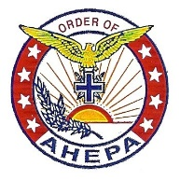
To promote and encourage loyalty to the United States of America; allegiance to its flags; support its Constitution’ obedience to its laws; reverence to its history; and to encourage its members to always be profoundly interested and actively participating in the political, civic, social, and commercial fields of human endeavor and always to strive for the betterment of society.

Hellenic
To always remember Hellas, the mother of civilization, the champion of Christianity and Democracy; to promote understanding of the Hellenic people and Nation and to revive, cultivate, enrich and marshal into active service to Humanity the noblest attributes and highest ideals of Hellenism.

Educational
To champion the cause of Education; to support the American system of public schools and to keep them free of religious prejudice; to promote and augment the educational advantages of this country; and to open, establish and maintain new channels for facilitating and dissemination of culture and learning.

Progressive
To instill progress in every one of its members and to utilize every means available for the perfection of the moral sense in its members; to promote good fellowship among them; and to endow them with the spirit of altruism, common understanding, mutual benevolence and helpfulness.

Association
To keep its members united, and to arouse mankind to the realization that tyranny, wherever it may exercise its baneful power, is menace to the life, prosperity, welfare, honor, and integrity of every citizen; and that the preservation of our liberties can be assured by being united and ready to back up our Government, the Champion of Liberty and the defender and protector of all oppressed and down-trodden people.

Visit Our District Website: www.ahepadistrict5.org

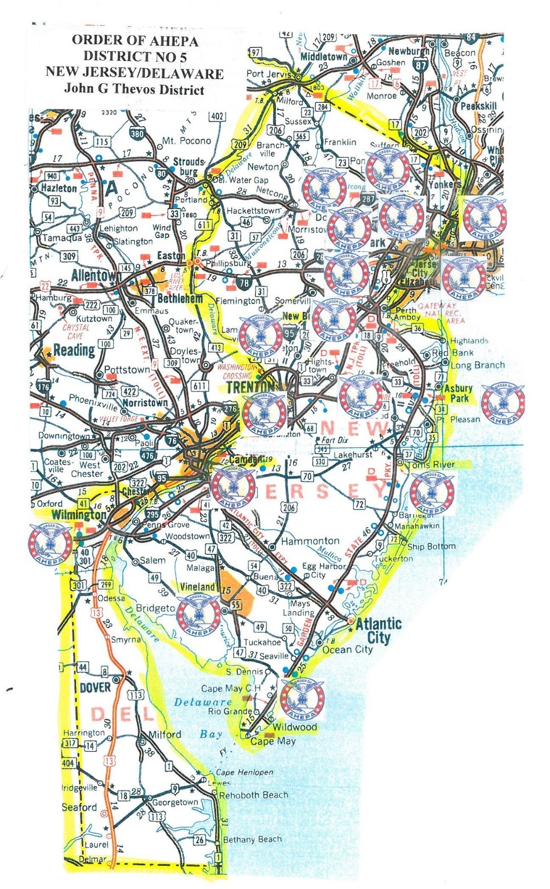
John G. Thevos District #5 2016-2017 District Directory

Visit Our District Website: www.ahepadistrict5.org

